

**Revo Registry Cleaner**

**User Guide**

*(Updated – 21 January 2025)*

***CONTENTS***

1. OVERVIEW 3

2. GRAPHIC USER INTERFACE (GUI) 4

3. REGISTRY CLEANER 4

3. REGISTRY TUNER 9

3.1 Windows Appearance 10

3.2 File Explorer 10

3.3 Desktop 11

3.4 Security and Stability 12

3.5 Windows Usage 13

3.6 System 13

4. REGISTRY WATCHER 14

5. BACKUP CENTER 16

6. MENU/OPTIONS 17

7. COMMAND LINE SUPPORT 20

8. HOW TO RESTORE A FULL REGISTRY BACKUP 21

9. REGISTRATION/ACTIVATION AND UPDATE SUBSCRIPTION 25

10. FREQUENTLY ASKED QUESTIONS (FAQ's) and TROUBLESHOOTING 29

# 1. OVERVIEW

Revo Registry Cleaner helps you to easily clean and maintain your Windows Registry, deleting invalid and leftover Registry entries, and optimizing your Windows performance and appearance. Cleaning such invalid data may help you resolve and avoid malfunctions and errors using your computer.

In a few words, the Windows Registry is the main database used by the Windows operating system and installed programs and apps to store any kind of data they need to function properly. We may say that the Registry is the backbone of the Windows operating system, where data as installed programs, their settings, installed hardware and devices, and all Windows system and appearance settings are stored.

For example, when a program is installed it writes its settings in the Registry, and its drivers and components are registered and installed writing specific data in the Registry. Later using, updating, uninstalling the program, or creating and manipulating various files with the program may cause many invalid Registry entries to appear. That may lower the performance of your computer and cause problems with existing or newly installed programs and the operating system. Keeping your Windows Registry in good shape may be vital for the daily usage of your PC no matter if it is for work or fun.

So, knowing how important the Registry is, having a Backup is mandatory. Hopefully, Windows has some built-in mechanisms to create some kind of backups, but you can easily manage it by yourself using the Revo Registry Cleaner module - Backup Center. It allows you to instantly create a backup of the whole Windows Registry or only a part of it – a key or a hive you are interested in. The Backup process may be scheduled and performed automatically regularly.

If you want to know what is being modified in your Registry and which program is responsible for that you may use the Revo Registry Cleaner module – Registry Watcher. It allows you to select parts of the Registry and to monitor and/or record all the activity inside, what is being changed, which are the old and new data, and which is the process that does the change, thus you can find some unwanted or even unauthorized changes to the Registry, made by software that is not supposed to do them.

Sometimes tuning the various options of the operating system can be challenging, as changes have to be made in the Registry - the storage of all Windows system settings. The module Registry Tuner allows you to easily and safely modify some parameters and settings of the Windows Operating system responsible for the security, appearance, and usage of the operating system, thus making it more convenient for the way you use your computer. Many of these settings can be changed only with direct modification of the Registry, but with the Registry Tuner, it is easy and safe to change and revert back the change if you do not like how it works for you.

# 2. GRAPHIC USER INTERFACE (GUI)

The main screen is divided into two – the **Commands Panel** and the **Active Tool Panel**. The upper part of the **Commands Panel** shows commands for the active tool shown as separate buttons. The lower part shows all the modules. Clicking on one will switch to the other. To open a module, click its button.

Upon starting the program the Registry Cleaner module is activated and you can see big icons of the different scanning modes.

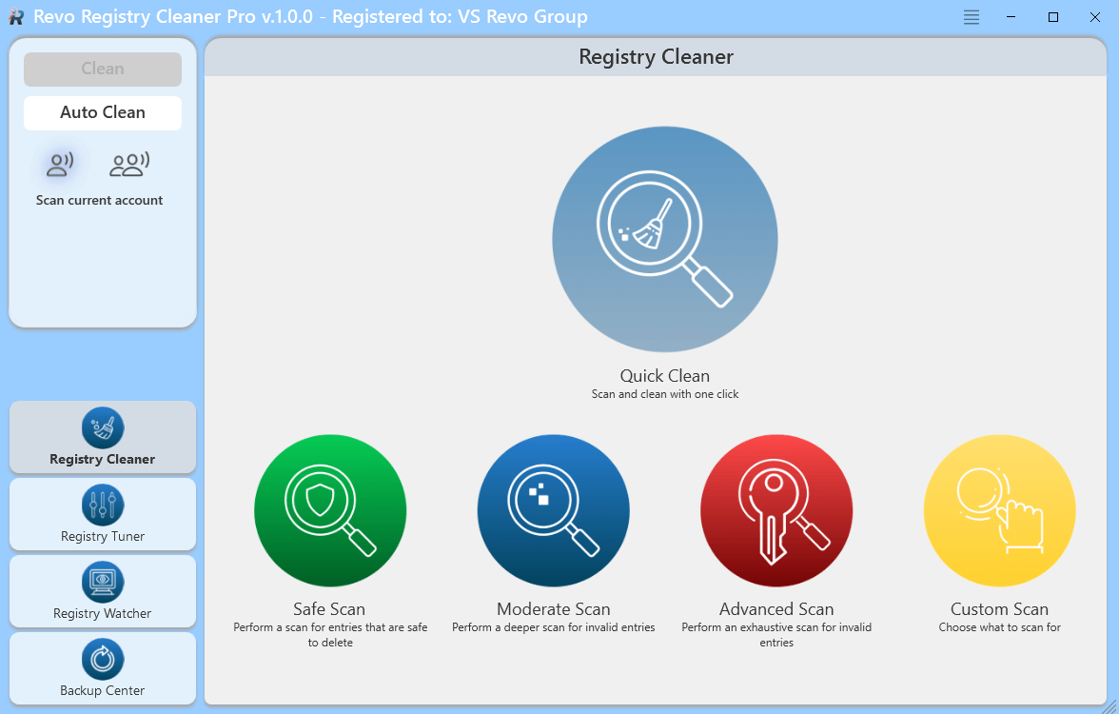

The **Menu** button is located in the upper-right corner of the title bar of the window, just on the left of the standard minimize button. It contains both essential and general commands, including user Options for the whole program.

Upon the first launch of the program, you will be asked to choose between the default/light and the dark user interface mode of Revo Registry Cleaner. The user interface colors can be customized separately, either manually or by using predefined themes, with an included Dark Mode (**Menu->Options->View->Theme**).

# 3. REGISTRY CLEANER

Upon starting the program, the Registry Cleaner module is activated by default and you can start scanning for unnecessary, obsolete, or broken Registry entries by clicking on the available scanning modes or executing the one-click operation “Quick Clean” that will scan your Registry, backup and clean all found issues without any more interaction from the user. In case you want to review found issues and control the cleaning process, there are three scanning modes based on how deep and complex you want the scan to be and a “Custom” mode that lets you choose areas of Registry leftovers to scan for.

**Safe mode** – the basic and fastest scan mode, that scans the common keys and values in Registry where unnecessary items may exist. It is recommended for beginners or users without any knowledge related to Windows Registry.

**Moderate mode** – the balanced mode, includes the Safe mode and performs an extended scan for unnecessary Registry items.

**Advanced mode** - includes the Moderate mode and performs a deep and thorough scan for unnecessary Registry items.

**Custom mode** – lets you choose the categories of Registry items to scan for based on their type and location.

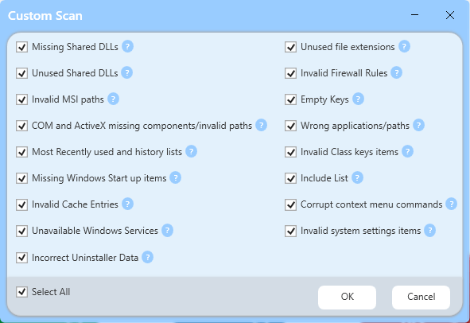

Categories available in the **Custom mode** are:

* **Missing Shared Dlls** – lists Shared dynamic-link libraries that do not exist on the system
* **Unused Shared Dlls** – lists Shared dynamic-link libraries whose usage counter is set to 0
* **Invalid MSI paths** – lists missing files and folders related to Microsoft software installer-based installations
* **COM and ActiveX missing components/invalid paths** – lists invalid registrations of COM and ActiveX components where file and related data is missing.
* **Most Recently used and history lists** – lists history of recently accessed files, visited paths, etc. in common Windows dialogs and programs.
* **Missing Windows Start-up items** – lists invalid paths of missing applications/services/files set to start up with Windows.
* **Invalid Cache entries** – lists cache entries that are no longer valid due to missing file/folder
* **Unavailable Windows Services** – lists data of corrupted Windows services due to missing files
* **Incorrect Uninstaller Data** – lists some invalid and useless uninstaller information
* **Unused file extensions** – lists file extensions that are not associated with any program
* **Invalid Firewall Rules** – lists Windows Firewall rules related to missing files or invalid paths.
* **Empty keys** – lists some software-related keys that do not contain any data
* **Wrong applications/paths** – lists invalid data related to missing application paths and files
* **Invalid Class keys items** – lists useless items related to invalid file types data and corrupted components with missing file/folder
* **Corrupted Context menu commands** – lists data related to context menu commands that will not work due to not existing file/folder
* **Invalid System settings items** – lists missing system settings items - sounds, themes, etc.
* **Include list** – lists all data from items set in **Options-> Registry Cleaner-> Include List**.

By default, the Registry is scanned only for the current user, but by clicking on the icons below the command buttons you can choose to scan the Registry for all users. After the scanning process has completed a tree with found Registry items. Parent nodes in bold are the categories with the number of found items in brackets. All found items in a category are presented as its sub-items. If you want to see the full path in the Registry of a found item you must expand it. If the found item is data of a Registry value you will see the Registry key and the value separated with a slash like this **|**

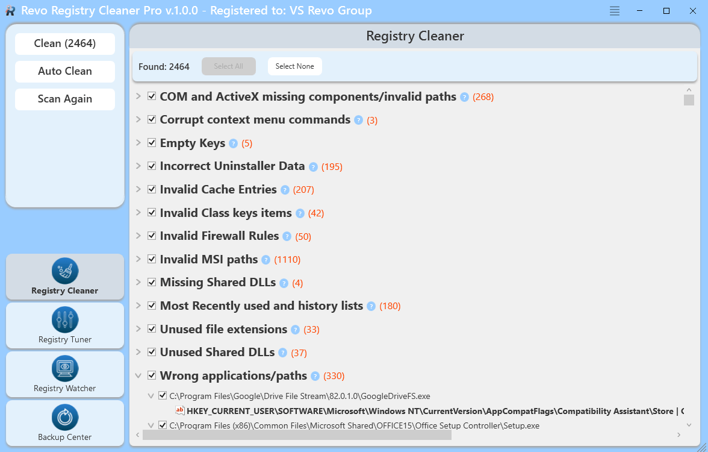

On the top of the screen with found items, you will see the total number of found items and a button that allows you to select or deselect all items in the list. You can also click on the check mark in front of any item to select or deselect it.

Right-click any item to open a context menu to help manage your decision-making. Most options are self-explanatory, but note the following:

**Unselect This** – Removes the check mark on current item

**Select All** – Selects all items in the list

**Select None** – Deselects all items in the list

**Collapse All** – Collapses the tree to the main items (categories)

**Expand All** – Expands all parent items in the tree so their children become visible

**Expand to Data** – Expands the whole tree, so all data is visible

**Open in Registry Editor…** – opens the key in the Windows Registry (regedit.exe).

**Add to exclude** list – adds the selected key to protect from deletion. You can edit the exclude list from the Options

**Export List to** – export the data to TXT, HTML, CSV, XML, and XLS

After you have selected the items you want to delete, you must press the Clean button in the left commands panel. The Clean button shows you in brackets the total number of selected items from the tree.   
Clicking on the Clean button you will be asked if you want to make a System Restore and Full Registry backup before the procedure of deleting unnecessary Registry items. By default, all deleted Registry items are backed up. Made backups are stored in the **Backup Center.**

Note: if the option **Skip warning messages shown by Revo Registry Cleaner** is unchecked you won’t be asked for the creation of System Restore and Full Registry backup, but the corresponding options in **Options-> Registry Cleaner-> General** will be used to determine, which backup will be done.

If you want to do a new scan press the **Scan Again** button in the **Commands Panel**. That will show you the home screen of the Registry Cleaner where you can choose the scanning mode

You can automate the process of scanning and cleaning your Registry using the command **Auto Clean** from the **Commands Panel** on the left.

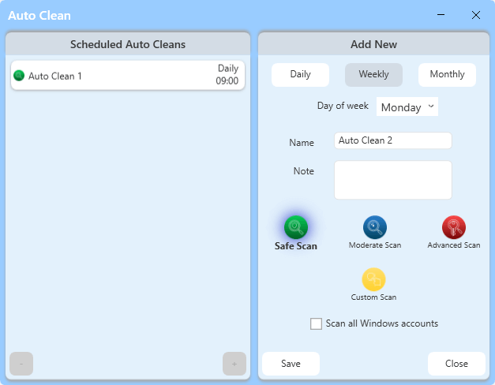

Once the command is executed you are shown a window divided into two parts. The left part shows a list of saved scheduled Auto Cleans, and the right part allows you to create and save a scheduled Auto Clean with different parameters, based on your needs. Every saved scheduled Auto Clean has a **Name**, you may write a **Note** and adjust if the clean operation is to be **Daily** at a specific time, **Weekly** at a specific day of the week, or **Monthly** at a specific date of any month. You can choose which scan mode to use for the scanning process and if only data for the current user account is to be cleaned or for all user accounts. Once the button **Save** is clicked the Auto Clean is saved and listed in the left part of the Auto Clean window. To **Edit** already saved and listed Auto Cleans, just select it from the list, and from the right part of the window, all parameters can be edited and re-saved. To **Delete** an Auto Clean select it from the list and click the “-“ button in the lower-left corner of the window.

While your computer is running after a successful Auto Clean operation when some invalid data is cleaned you will be shown a small notification that appears in the lower-right part of the desktop window for a few seconds to notify you which Auto Clean operation has successfully completed and what are the results.

# 3. REGISTRY TUNER

The Registry Tuner gives you access to more than 50 tweaks and options that can easily optimize the settings of the Windows Operating System. Starting the module from the button in the lower part of the command panel you see a list with six categories where all tweaks are grouped and the first one – Windows Appearance is opened on the right in a list of tweaks. Most of the tweaks in the Registry Tuner are just turned on/off with a single click over a slider, for some of them there is a drop-down button with a few possible options to choose from. A small text field “**by Revo Registry Cleaner**” is just below the modification control. Depending on the type and scope of the tweak, some of them require you to log out, restart Windows Explorer, or restart your computer for it to take effect. You will be informed by a small text in red in the lower part of the list of items you have modified. Such action buttons are available on the command panel on the left, so if such action is required the corresponding button is enabled and must be clicked if you want to change to take effect.

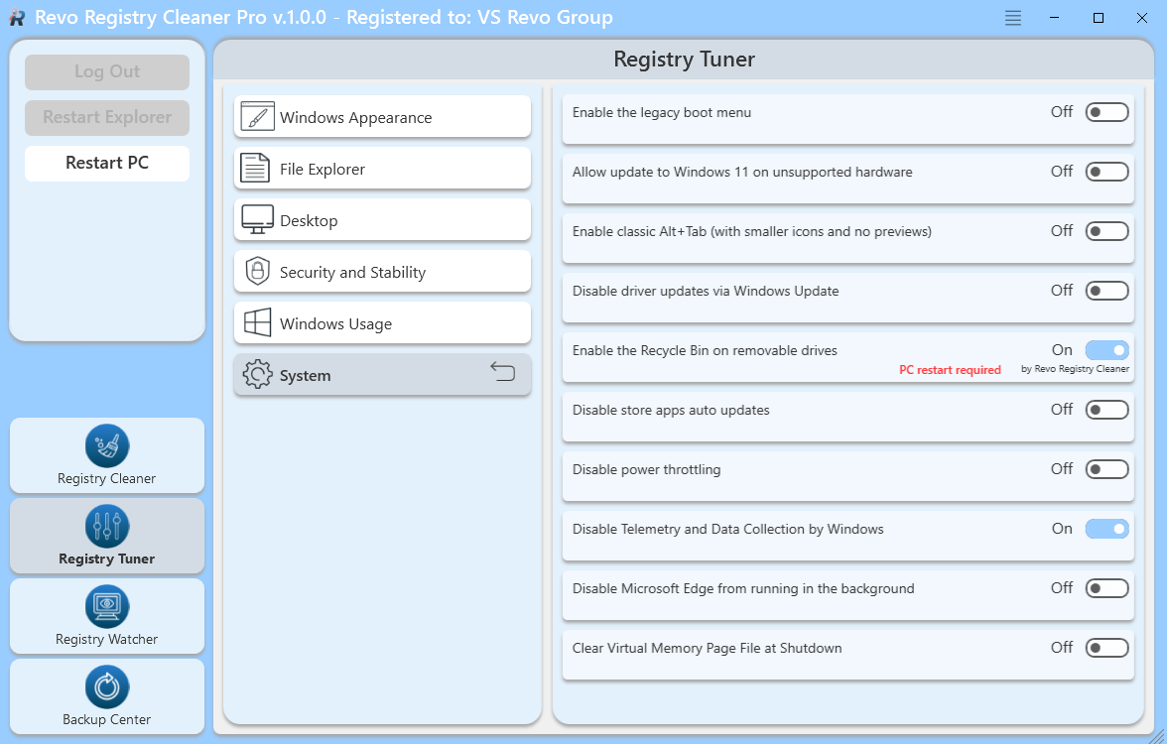

# 3.1 Windows Appearance

Contains the following tweaks:

* **Speed up aero snap to make thumbnail display faster** - [Available on Windows 7;8,1;10;11], [Requires to Restart Explorer] - On hover show thumbnails of opened windows on the taskbar faster.
* **Boost display speed on Aero peek**  - [Available on Windows 7;8,1;10;11] - Aero peak will be shown faster.
* **Speed up Windows menus** - [Available on Windows 7;8,1;10;11] - Minimize the delay when Windows menus are shown
* **Enable Windows 10 like context menu** -[Available on Windows 11], [Requires to Restart Explorer] - Use this option to revert back to the old context menu like in Windows 10
* **Disable Ads in Windows 11** -[Available on Windows 11], [Requires to Log Off / Log On] - Windows shows various types of ads and automatically installs apps from the Windows Store to promote them. Use these options to disable those features
* **Disable Blur on Sign-in Screen 11** -[Available on Windows 10;11], [Requires to Log Off / Log On] - The sign-in screen shows its background image with the blur effect applied. Turn on to disable this feature.
* **Use classic battery indicator and power applet** -[Available on Windows 10;11], [Requires to Log Off / Log On] - If you don’t like the modern look of battery indicator and power applet. Use this option to enable the old one.
* **Enable Battery Life Estimated Time** -[Available on Windows 7;8,1;10;11], [Requires to Log Off / Log On] - Turn on if you want to see the battery lifetime remaining in both the battery saver flyout and the battery power icon tooltip.
* **Enable classic volume control** - [Available on Windows 10] - Enable the old volume control in Windows 10 instead of the modern-looking sound applet.
* **Disable Widgets in Windows 11** -[Available on Windows 11], [Requires to Log Off / Log On] - If you don’t need any widgets or find them annoying. Enable this feature to hide them.

# 3.2 File Explorer

Contains the following tweaks:

* **Disable Tabs in File Explorer** -[Available on Windows 10;11] - If you don’t need any widgets or find them annoying. Enable this feature to hide them.
* **Disable the “SV2 Navigation Pane”** -[Available on Windows 7;8,1;10;11] - Use this feature to hide the navigation pane from File Explorer.
* **Disable “You have new apps that can open this type of file”** -[Available on Windows 7;8,1;10;11], [Requires to Log Off / Log On] - Turn on to disable the notification for newly installed apps.
* **Add “Command Prompt As Administrator” in Context Menu** -[Available on Windows 7;8,1;10;11] - You can add the “Command Prompt As Administrator“ command to the context menu of File Explorer. This will open a new command prompt with administrator privileges in the current directory.
* **Set “Do this for all current items” checked by default** -[Available on Windows 7;8,1;10;11] - Using this option you can enable the “Do this for all current items” checkbox by default in the file operation conflict dialog.
* **Enable Auto-Completion in File Explorer** -[Available on Windows 7;8,1;10;11], [Requires to Log Off / Log On] - Enabling this feature will automatically append suggested text to the text you type in the address bar, run dialog, open and save file dialogs.
* **Open File Explorer to This PC, OneDrive, Downloads, or Quick Access Explorer** -[Available on Windows 10;11] - Choose which location the File Explorer will open when a new instance is started.
* **Disable Pop-Up Descriptions** -[Available on Windows 7;8,1;10;11], [Requires to Restart Explorer] - Disable the info popup tips when you keep the mouse over some file or folder.
* **Show Drive Letters First** -[Available on Windows 7;8,1;10;11], [Requires to Restart Explorer] - Use this option if you want to see the drive letter before its drive name.
* **Show Full Details When Deleting a File** -[Available on Windows 7;8,1;10], [Requires to Restart Explorer] - If enabled, Windows will show you more details when deleting a file.
* **Add Rotate Right/Left image to context menu** -[Available on Windows 7;8,1;10] - If you have images/photos that need to be rotated. Use this option to add an easy way to do it through the context menu.
* **Enable Classic File Explorer Ribbon** -[Available on Windows 11], [Requires to Restart Explorer] - Turn this option on if you prefer the tabbed File Explorer in Windows 10.

# 3.3 Desktop

Contains the following tweaks:

* **Speed up mouse hover action by Windows** -[Available on Windows 7;8,1;10;11], [Requires to Log Off / Log On] - Force Windows to execute mouse hover actions faster like showing tooltips or thumbnails.
* **Speed up desktop and folders loading by improving system icon cache** -[Available on Windows 7;8,1;10;11] - Increase icon cache to improve the speed of loading folders and the desktop.
* **Disable Bing in the Taskbar search** -[Available on Windows 10;11], [Requires to Log Off / Log On] - Turn on to disable search in Bing while typing in the taskbar.
* **Show seconds in taskbar clock** -[Available on Windows 10;11], [Requires to Restart Explorer (Windows 10)] - Turn on to show seconds in the system clock on the taskbar.
* **Show Windows version on desktop** -[Available on Windows 7;8,1;10;11], [Requires to Log Off / Log On (Windows 11 - Restart Explorer)] - Easily see which version of Windows OS you are running by displaying it on the right bottom corner of the desktop.
* **Show Windows Defender tray icon** -[Available on Windows 10], [Requires to Log Off / Log On] - If you are missing the Windows Defender icon in the tray you can show it by enabling this option.
* **Move the Taskbar to a different location** -[Available on Windows 10], [Requires to Restart Explorer] - Using this you will be able to move your Taskbar left, right, or top.

# 3.4 Security and Stability

Contains the following tweaks:

* **Disable AutoPlay feature on drives to avoid virus injection** -[Available on Windows 7;8,1;10;11] - Improve system security by removing the AutoPlay feature on removable devices.
* **Close frozen processes to avoid system crashes** -[Available on Windows 7;10;11] - Use this feature to enable auto closing of unresponsive processes.
* **Disable the security warning and blocking of downloaded files** -[Available on Windows 7;10;11] - Suppress showing of warnings and blocking of downloaded files.
* **Add the “Take Ownership” option in the File Explorer context menu** -[Available on Windows 7;8,1;10;11] - Add the “Take Ownership“ context menu to files and folders to quickly gain full access to them.
* **Disable SmartScreen in Windows 11** -[Available on Windows 11], [Requires to Log Off / Log On] - Turn on to disable the SmartScreen security feature in Windows, MS Edge, and Windows Store.
* **Show BSOD details instead of the sad smiley in case of a blue screen error** -[Available on Windows 10;11], [Requires to Restart PC] - Turn on If you want to turn on the old style Blue Screen of Death and disable the sad emoticon.
* **Enable access to network drives from elevated apps running as administrator** -[Available on Windows 7;8,1;10;11], [Requires to Log Off / Log On] - Turn on to grant access to network drives from elevated apps running as administrator.
* **Disable User Account Control (UAC)** -[Available on Windows 7;8,1;10;11], [Requires to Restart PC] - Turn on If you want to turn on the old style Blue Screen of Death and disable the sad emoticon.
* **Enable Adware protection feature in Windows Defender** -[Available on Windows 10;11], [Requires to Log Off / Log On] - Turn on to activate Windows Defender Adware blocker.
* **Enable USB Write Protection** -[Available on Windows 7;8,1;10;11], [Requires to Restart PC] - Once enabled you will restrict write access to USB mass storage devices.
* **Enable Camera On/Off notification** -[Available on Windows 7;8,1;10;11], [Requires to Log Off / Log On] - Turn on to get notified every time the camera is turned on or off.
* **Disable AutoEndTasks at Shut Down, Restart, or Sign Out** -[Available on Windows 7;8,1;10;11], [Requires to Log Off / Log On] - Minimize the risk of losing data or unsaved progress by disabling the Auto End Tasks feature.

# 3.5 Windows Usage

Contains the following tweaks:

* **Activate Windows Photo Viewer** -[Available on Windows 10;11] - Enable to activate the Windows Photo Viewer as a default image viewer in Windows 10 and 11.
* **Disable Windows Background Apps to conserve power** -[Available on Windows 8.1;10;11] - Turn on to disable the possibility of apps running in the background thus optimizing power consumption.
* **Disable property handles extraction for media files** -[Available on Windows 7;8.1;10;11] - Turn on if you have folders with various media files and do not want to wait for Windows to extract metadata from them, thus slowing the loading of files.
* **Add Classic User Accounts to Control Panel** -[Available on Windows 7;8.1;10;11] - Enabling this option adds Classic User Accounts to Control Panel.
* **Disable “- Shortcut” text for new shortcuts** -[Available on Windows 7;8,1;10;11], [Requires to Restart Explorer] - Use this option to remove “- Shortcut“ text from newly created shortcuts.
* **Disable “This App is Preventing Shutdown or Restart” Screen** -[Available on Windows 7;8,1;10;11] - Turn this option on to disable the screen that appears when you try to log off, restart, or shut down in Windows OS and shows a list of apps that are preventing the operation.

# 3.6 System

Contains the following tweaks:

* **Enable Legacy Boot Menu** -[Available on Windows 10;11] - Switch to the Legacy Boot Menu Policy that allows pressing the F8 key during boot to bring up the boot menu to enter Safe Mode, etc. By default, in Windows 10 and 11 this is disabled.
* **Allow the update to Windows 11 on unsupported hardware** -[Available on Windows 10] - Allow Windows 11 update on systems that may be somewhat older but have adequate hardware (CPU, memory, SSD) to run Windows 11, they simply lack the necessary Trusted Platform Module (TPM).
* **Enable classic Alt+Tab (with smaller icons and no previews)** -[Available on Windows 7;10;11], [Requires to Restart Explorer] - Turn on if you dislike the new UI for alt-tabbing with the large previews, and instead prefer the previous UI with the small icons.
* **Disable driver updates via Windows Update** -[Available on Windows 7;10;11], [Requires to Log Off / Log On] - Turn on to take control of driver updates by disabling the automatic updates through Windows Update.
* **Enable the Recycle Bin on Removable Drives** -[Available on Windows 7;8,1;10;11], [Requires to PC] - Useful to prevent permanent deletion of important data from removable drives.
* **Disable Store apps auto-updates** -[Available on Windows 10;11], [Requires to Log Off / Log On] - Turn on to prevent Windows from updating Store apps automatically without your confirmation. You can update apps manually and only if you want to.
* **Disable Power Throttling** -[Available on Windows 7;8,1;10;11], [Requires to Log Off / Log On] - Power Throttling limits the resources used by inactive apps. There is an algorithm that detects active tasks and keeps them running while all other processes are throttled. You can disable this feature to prevent some issues with those processes.
* **Disable Telemetry and Data Collection by Windows** -[Available on Windows 7;8,1;10;11], [Requires to Log Off / Log On] - Power Throttling limits the resources used by inactive apps. There is an algorithm that detects active tasks and keeps them running while all other processes are throttled. You can disable this feature to prevent some issues with those processes.
* **Disable Chromium Microsoft Edge From Running in The Background** -[Available on Windows 7;8,1;10;11], [Requires to Log Off / Log On] - Turn on to stop Microsoft Edge from running in the background all the time.
* **Clear Virtual Memory Page File at Shutdown** -[Available on Windows 7;8,1;10;11], [Requires to Log Off / Log On] - This option will save some space on your main drive but it will probably lead to an increase in time needed to shut down.

# 4. REGISTRY WATCHER

Using the Registry Watcher module, you can easily track what changes are made in the Registry and which process is doing them. Click on the **Registry Tuner** button in the lower part of the Command Panel to activate the module. The screen of the module is separated into four main parts. On the top left is the Registry tree where you can navigate to find the key you are interested in. To start monitoring a key you need to select it and press the arrow button that is in the panel on the right of the Registry tree. That moves the selected key to the top right pane where you see the keys that you have already added for monitoring. In the top center panel, there is also a **Pause/Start** monitoring button and a **Delete** button that affect the keys in the list of monitored items.

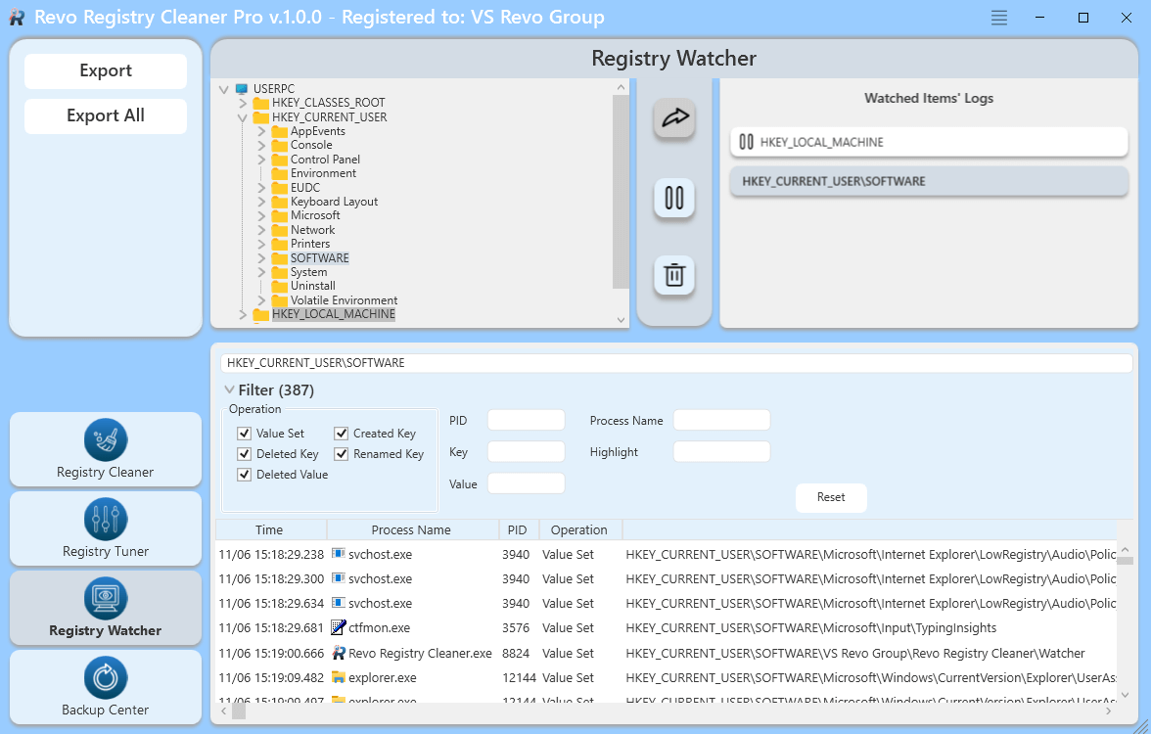

After a key is added for tracking, its monitoring starts immediately. To pause it you can select it from the top right panel and press the **Pause** button, transforming it into a **Start** button, in case you want to resume the monitoring again. If you do not want to monitor a key anymore you can delete it from the list with the **Delete** button.

In the lower part of the screen on the module is the **Result** **Pane** with **Filter** options Its content is updated in real-time showing data captured for the currently selected tracked key with many properties like Time of modification, Process Name, PID (Process ID), Registry Operation, Registry Key, Registry Value, Value New Data, Value Old Data, Value Data type

In the upper part of the pane is the **Filter** section, which can be used to be filtered based on almost all tracked parameters. Also, from the **Highlight** field some text of interest may be highlighted. Monitored data for the chosen Registry key can be exported using the context menu command “**Export List to File**”. Supported formats are TXT, CSV, and XLSX.

Also from the context menu currently shown captured data can be cleared with the context menu command “**Clean**” and any Registry key can be opened in the Windows Registry Editor using the command **“Open in the Registry Editor…”**

All the captured data for all monitored keys may be exported using the button from the command panel – **Export All**. Supported formats are TXT, CSV, and XLSX.

# 5. BACKUP CENTER

The Backup Center module lets you create and manage different types of Registry backups done during operations of the Revo Registry Cleaner or intentionally by you. You can start it with a click of the lowest modules button in the Command Panel. Its main screen shows sorted by date all made backups with their properties.

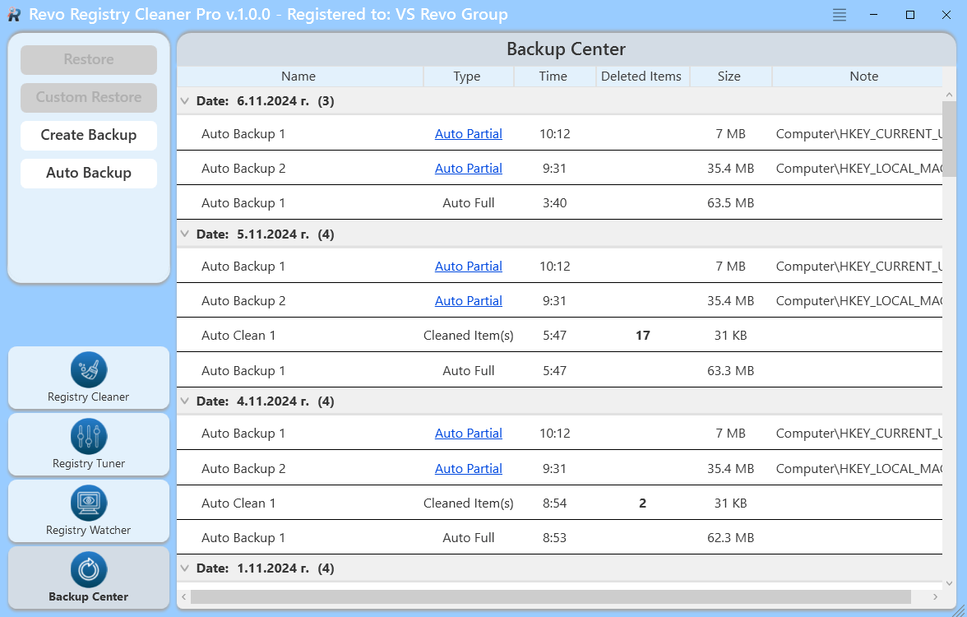

From the Command Panel, you can create a new partial or full Registry backup by clicking on the **Create Backup** button. It opens a window to choose the name of the backup, to write a note if you want, and use the check mark “**Backup Whole Registry**” to choose to backup the whole Windows Registry or backup a specific key. If you choose to backup a specific key you are shown the Registry tree and keys that can be backed up are in black, the ones that are not allowed are in gray font color.

You can automate the process of creation of backups of your Registry using the command **Auto Backup** from the **Commands Panel** on the left. Once the command is executed you are shown a window divided into two parts. The left part shows a list of saved scheduled Auto Backups and the right part allows you to create and save a scheduled Auto Backup with different parameters, based on your needs. Every saved scheduled Auto Backup has a **Name**, you may write a **Note** and adjust if the clean operation is to be **Daily** at a specific time, **Weekly** at a specific day of the week, or **Monthly** at a specific date of any month. Using the check mark “**Backup Whole Registry**” You can choose to backup the whole Windows Registry or backup a specific key. If you choose to backup a specific key you are shown the Registry tree and keys that can be backed up are in black, the ones that are not allowed are in gray font color. Once the button **Save** is clicked the Auto Backup is saved and listed in the left part of the Auto Backup window. To **Edit** already saved and listed Auto Backups, just select it from the list, and from the right part of the window, all parameters can be edited and re-saved. To **Delete** an Auto Backup select it from the list and click the “-“ button in the lower-left corner of the window.

While your computer is running after a successful Auto Backup you will be shown a small notification that appears in the lower-right part of the desktop window for a few seconds to notify you which Auto Backup operation has successfully completed.

Navigating in the list of done backups you can choose to restore all data from a backup by selecting it and using the “**Restore**” button from the **Commands Panel** or just a part of it using the “**Custom** **Restore**” button from the **Commands Panel** To restore whole data select it from the list and click the Restore button on the top of commands panel. To restore only part of the data backed up in that backup, select it and click Custom Restore. That will open.

Using the context menu is another way to execute “Restore” and “Customs Restore” commands, and also to delete one backup using the “**Delete**” command or all using “**Delete All**”

# 6. MENU/OPTIONS

To view all Revo Registry Cleaner’s Options, click the Menu button  in the top right corner and select Options.

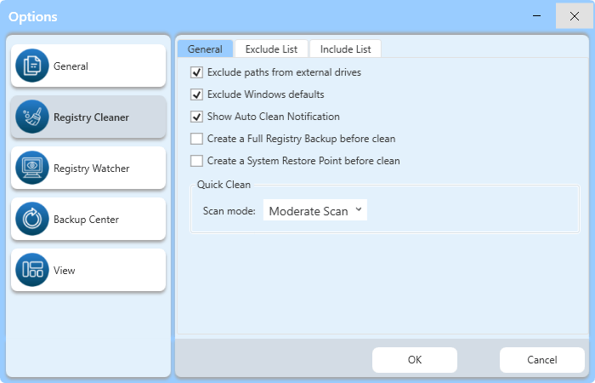

The remaining menu items are self-explanatory.

**6.1 G****eneral**

Provides general options for Revo Registry Cleaner:

* **Current Language** – drop-down menu with all available languages for Revo Registry Cleaner.
* **Check for updates on startup** – checks whether a new version is available, by connecting to www.revouninstaller.com on startup, but only once per day. No personal information is sent.

***Note: you must allow Revo Registry Cleaner to connect to the Internet in your firewall.***

* **Update automatically in the background** – enables automatic download and update of Revo Registry Cleaner. You will be notified on the next startup of the program if such an update has occurred.
* **Skip warning messages shown by Revo Registry Cleaner** – enable this option if you do not want to receive warning messages. For example: “Are you sure you want to delete the selected item?”

**6.2 Registry Cleaner**

**6.2.1 Registry Cleaner (General)**

* **Exclude paths from external drives** – if enabled: during scanning for invalid and unnecessary items paths that are from external devices even, though they do not exist at the moment, won’t be listed to protect your software\data stored on removable\external drives.
* **Exclude Windows defaults** – if enabled: for additional protection, during scanning for invalid and unnecessary items, Windows-related paths that are invalid, but exist for backward compatibility or other reasons and are in most cases recreated are excluded.
* **Show Auto Clean Notification** – this option controls whether notifications for completed scheduled Auto Clean operations are shown or not.
* **Create a System Restore Point before cleaning** – if Windows System Restore is enabled, Revo Registry Cleaner sends a request to create a System Restore Point.
* **Create a full Registry backup before cleaning** – if enabled: create a full Registry backup which can be used to restore via the Windows Recovery Console.
* **[Quick Clean] Scan Mode:** – select which mode for scanning will be used during the **Quick Clean** operation.

**6.2.2 Registry Cleaner (Exclude List)**

During the scanning operation with the Registry Cleaner keys from the exclude list won’t be scanned. You can add or remove items to/from this list using the Add and Remove buttons.

A Registry key can only be excluded by adding the full path to the key. For example:

HKEY_LOCAL_MACHINE\SOFTWARE\Classes

There is an option for each Registry key called Include Sub keys. If enabled, this will also exclude all sub-keys of the selected Registry key.

In front of each Registry key, there is a check box, which is used to enable or disable the exclusion of the corresponding Registry key. If there is a check mark, the key is excluded.

**6.2.3 Registry Cleaner (Include List)**

If you want to clear the content of specific keys using the Registry Cleaner, you can add them to the **Include list.**   
Note: The Include List is processed only in **Custom Scan** if the category **Include List** is selected.

A Registry key can only be included by adding the full path to the key. For example:

HKEY_LOCAL_MACHINE\SOFTWARE\Test

There is an option for each Registry key called **Include Sub keys**. If enabled, all sub-keys of the selected Registry key will be emptied too.

In front of each Registry key, there is a check box, which is used to enable or disable the inclusion of the corresponding Registry key. If there is a check mark, the key is included.

**IMPORTANT: Be sure you know what you are doing by adding a key to the Include list as data inside and based on the option their sub-keys will be deleted when Custom Scan is executed and the category Include List is selected.**

**6.3 Registry Watcher**

* **Maximum logs' folder size XX MB** – you can set the maximum size in Megabytes of all logs made from the **Registry Watcher.** When that limit is reached all currently monitored keys are automatically paused.

**6.4 Backup Center**

* **Backup Folder:** – Enter the path to a folder or use the **Browse** button to select a folder where backups are stored.
* **Auto Delete Backups** – to free up space backups can be automatically deleted when one or more conditions are met:
  + **When older than XX days** – if enabled: backups older than the entered number of days will be automatically deleted.
  + **When all backups are larger than** **XX MB** – if enabled: when the backup folder reaches the size of the entered Megabytes older backups will be automatically deleted.
  + **Delete only Auto Backups** – if enabled: only scheduled Auto Backups will be automatically deleted. This option can be modified only in combination with one of the above options.
* **Show Auto Clean Notification** – this option controls if notification for scheduled Auto Backup is shown or not.

**6.5 View**

* **Theme** – you can choose a min color theme for the user interface of the program. Available are: Default, Dark, Green, Gray, Black.
* **Reset default view settings** – reset most of the changes made to the user interface of Revo Registry Cleaner.

# 7. COMMAND LINE SUPPORT

Some Revo Registry Cleaner operations can be executed from a command line. Supported command line operations and their arguments are:

**Registry Clean** - you can clean found as unnecessary and obsolete Registry items specifying desired scanning mode. All found items are automatically backed up and deleted

Syntax:

Revo Registry Cleaner -**clean** -**scanning mode** -**affected accounts**

Where the parameters are:

-**clean** – operation type

-**mode** - mode of the scanning - safe, moderate, or advanced are possible parameters

-**affected accounts** – if this parameter is missing current Windows account is cleaned. Or add “**all**” to scan and clean all Windows accounts

**Examples**:

”Revo Registry Cleaner.exe” -clean -safe → Safe scan for current user

”Revo Registry Cleaner.exe” -clean -moderate -all → Moderate scan for all users

**Registry Backup** - you can create full or partial Registry backup

Syntax:

Revo Registry Cleaner -**backup** -**type** “Registry path”

Where the parameters are:

- **backup** – operation type

- **type** – if specified “**full**” full backup is done, if specified “**key**” a Registry key must follow

**Examples**:

”Revo Registry Cleaner.exe” -backup -full → Creates Full Registry Backup

“Revo Registry Cleaner.exe” -backup -key HKEY_CURRENT_USER\Control Panel → creates backup of the key HKEY_CURRENT_USER\Control Panel

**Registry Watch** - you can start and stop watching changes in a specified Registry key

Syntax:

Revo Registry Cleaner -**watch** -**action** “Registry path”

Where the parameters are:

- **watch**– operation type

- **action** – if missing it is considered as start action, or “**stop**” a Registry key must follow

**Examples**:

"Revo Registry Cleaner.exe" -watch HKEY_CURRENT_USER → starts watching HKEY_CURRENT_USER

"Revo Registry Cleaner.exe" -watch -stop HKEY_CURRENT_USER → stops watching HKEY_CURRENT_USER

# 8. HOW TO RESTORE A FULL REGISTRY BACKUP

Revo Registry Cleaner can create a Full Registry Backup before every clean operation depending on your settings and from the **Backup Center**

***IMPORTANT: Full Registry backups should only be used if Windows Restore/Backup Manager cannot restore removed items, or if Windows no longer starts properly.***

***NOTE: The procedure to restore a full Registry backup will vary depending upon the version of your computer's operating system, as follows:***

**8.1 For Windows 7**

1. Choose which full Registry backup you want to restore from the Backup Center.
2. Click the “Restore“ button.
3. Restart the computer. When the machine first starts again, it will generally list some equipment installed on your machine, the amount of memory, hard drives installed, etc. At this point, you should tap the F8 key repeatedly until you are presented with a Windows Advanced Options menu.

***NOTE: Some OEM computers can use a different function key to F8, so refer to the instructions that came with your computer.***

1. Select the **Repair Your Computer** option.
2. Follow screen instructions until you see the **System Recovery Options** window.

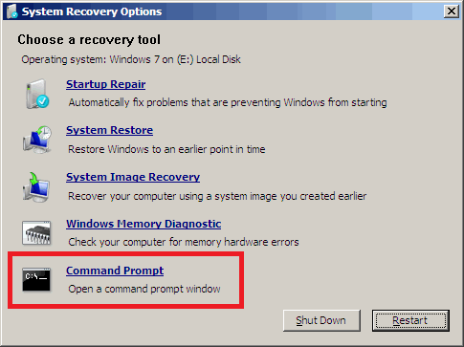

1. Select **Command Prompt** to restore a full Registry backup.  
     
   Enter (type) each of the following commands (in **bold**). Press Enter after each step:  
     *(Assuming you have installed Windows on “Local Disk (C :)”)  
    Step 1*: **C:**

*Step 2*: **CD Users**  
 *Step 3*: **DIR**

*(A list with folder names will appear, including your user name, remember it for the next step.)**Step 4*: **CD “XXX\AppData\Local\VS Revo Group\** **Revo Registry Cleaner\Backups\Last\”**

*(Replace* ***XXX*** *with your user name found in step 3. Ensure you include the quotation marks above.)*  
  
For Revo Registry Cleaner Portable – you should navigate the chosen by yourself folder(as an example):

**C:\Users\User\Desktop\Revo Registry Cleaner Portable\Data\UserXXX\Backups\Last\**  
  
 *Step 5*: **ren Restore.dat Restore.bat**

*Step 6:***Restore.bat**

**8.2 For Windows 8 and Windows 10**

You need to start the computer in an unusual way to find the **Command Prompt** option.

Begin by pressing and holding the **Shift** key and only then may you reboot your computer as normal. Continue to hold the key down until the computer fully restarts and you see the **Choose an Option** screen.

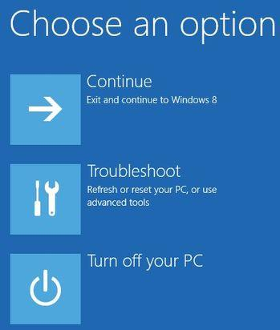

**N**ow proceed as follows:

1 - Click the **Troubleshoot** button.

2 - Click the **Advanced Options** button.

3 - Click the **Command Prompt** button.

4 - Log into your account, and you will see the **Command Prompt** window.

1. Enter (type) each of the following commands (in **bold**). Press Enter after each step:  
     *(Assuming you have installed Windows on “Local Disk (C :)”)  
    Step 1*: **C:**

*Step 2*: **CD Users**  
 *Step 3*: **DIR**

*(A list with folder names will appear, including your user name, remember it for the next step.)**Step 4*: **CD “XXX\AppData\Local\VS Revo Group\** **Revo Registry Cleaner\Backups\Last\”**

*(Replace* ***XXX*** *with your user name found in step 3. Ensure you include the quotation marks above.)*  
  
For Revo Registry Cleaner Portable – you should navigate to the chosen by yourself folder(as an example):

**C:\Users\User\Desktop\Revo Registry Cleaner Portable\Data\UserXXX\Backups\Last\**  
  
 *Step 5*: **ren Restore.dat Restore.bat**

*Step 6:***Restore.bat**

**8.3 For Windows 10 and Windows 11**

You need to start the computer in an unusual way to find the **Command Prompt** option.

Begin by pressing and holding the **Shift** key and only then may you reboot your computer as normal. Continue to hold the key down until the computer fully restarts and you see the **Choose an Option** screen.



**N**ow proceed as follows:

1 - Click the **Troubleshoot** button.

2 - Click the **Advanced Options** button.

3 - Click the **Command Prompt** button.

4 - Log into your account, and you will see the **Command Prompt** window.

* Enter (type) each of the following commands (in **bold**). Press Enter after each step:  
    *(Assuming you have installed Windows on “Local Disk (C :)”)  
  Step 1*: **C:**
* *Step 2*: **CD “Program Files”**
* *Step 3:* **CD “VS Revo Group”**
* *Step 4:* **CD “Revo Registry Cleaner“**

For **Revo Registry Cleaner Portable** – you should navigate the chosen by yourself folder(as example):  
**C:\Users\User\Desktop\Revo Registry Cleaner** **Portable\x64”**  
Or  
**C:\Users\User\Desktop\Revo Registry Cleaner** **Portable\x86” (for 32 bits systems)**

* *Step 5*: **RRCRestore.exe**
* *Step 6:* **Select backup you want to restore**
* *Step 7:* **Click “Restore“**

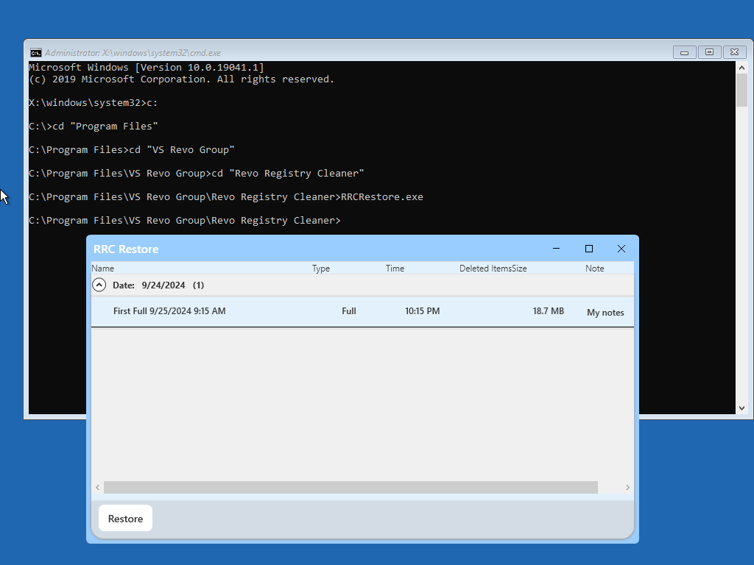

# 9. REGISTRATION/ACTIVATION AND UPDATE SUBSCRIPTION

Revo Registry Cleaner Pro has a 30-day free and fully functional trial period, during which you can use it without any restrictions. The trial period automatically starts on the first installation of the program on a particular system.

You can check the title bar on the top of Revo Registry Cleaner Pro’s main window to see how many days you have until the end of the trial period, and every time you close Revo Registry Cleaner Pro, you will see a reminder notifying you how many days you have left.

If you want to continue using Revo Registry Cleaner Pro after the trial period has ended, you will have to purchase a license from our website – [www.revouninstaller.com](http://www.revouninstaller.com).

When you purchase a license, you will receive a **Serial Number** with a specific update subscription period, which you must enter in the registration form in Revo Registry Cleaner Pro, together with a registration name (user name). There are two possible ways to activate or update your subscription to Revo Registry Cleaner Pro - to activate it online or to activate it by a specially generated file by Revo Registry Cleaner Pro.

Once activated, your version of Revo Registry Cleaner Pro will work without a time limitation, but you will be able to update it only to the latest released version during your subscription period. After that period’s expiration, you will not be able to install newer versions of Revo Registry Cleaner Pro, released after the date of expiration. You can check the subscription duration of your license if you click the **Menu button** on the top right of the main window, and select **About**.

If you decide to renew (extend) the update subscription period of Revo Registry Cleaner Pro, but it has not yet expired, the subscription period of the newly entered **Serial number** will be added to the remaining days of your current update subscription period.

If you have any questions or problems activating Revo Registry Cleaner Pro please do not hesitate to contact us at [support@revoregcleaner.com](mailto:support@revoregcleaner.com) or [registration@revoregcleaner.com](mailto:registration@revoregcleaner.com%20). Please, include details of your purchase, like full name, order ID, e-mail, and License Key received from us.

**9.1 Activate Online**

To activate Revo Registry Cleaner Pro online, you must first select that option in the Registration window (it is selected by default), and must have permissions to access the Internet, so it should be allowed in your firewall.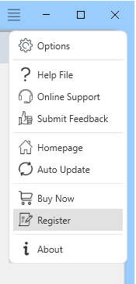

To open the **Register/Update Subscription Form**, and enter the **Serial Number** and your **Name** you have to:

1. Run Revo Registry Cleaner Pro.
2. Click the **Menu** button.
3. Choose **Register or Update Subscription**.

Another way to open the registration window is to click the Register link, on the left of the Menu button.

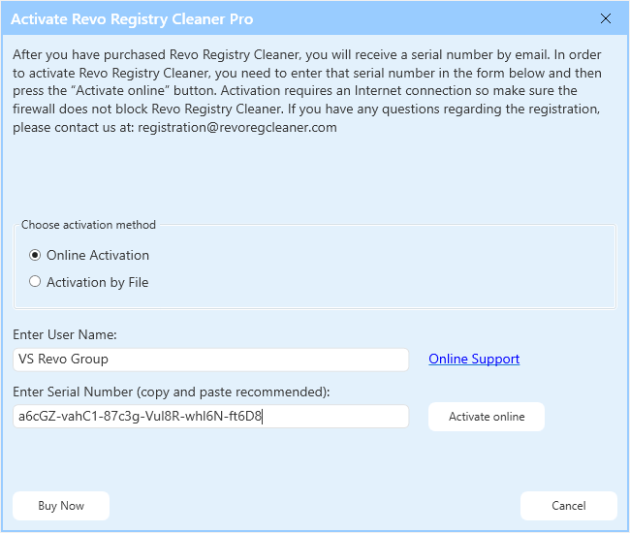

In the first field, you need to enter a user name. The user name can be whatever you wish. In the second field, you need to enter your serial number.

**IMPORTANT: the serial number contains lower and upper case characters, as well as numbers, and it is case-sensitive. Thus, we recommend that you copy and paste the serial number from the received email, as that is easier, faster, and more reliable than typing it manually.**

After you have filled out both fields, click the **Activate Online** button. You will see a text in the registration window saying that Revo Registry Cleaner Pro is contacting its server for activation.

The activation requires an Internet connection because Revo Registry Cleaner Pro needs to contact our activation server to validate your License.

If your computer does not have an Internet connection, you have another option to activate Revo Registry Cleaner Pro - **Activation by File**.

**9.2 Activation by File**

To activate or update a subscription to Revo Registry Cleaner Pro by file, first you must select that option from the Registration window.

To open the **Registration/Update Subscription Form**, and enter the **Serial Number** and your **Name** you have to:

1. Run **Revo Registry Cleaner Pro**.
2. Click the **Menu button**.
3. Choose **Registration** or **Update Subscription.**

In the first field, you need to enter a user name. The user name can be whatever you wish. In the second field, you need to enter your serial number.

After you have filled out both fields, click the **Save File** button. This will bring up a window that will allow you to save a .rrcaf file with a name and location of your choice. After you save the file, send it to us by email (to [registration@revoregcleaner.com](mailto:registration@revoregcleaner.com) ), and we will send you back the **Unlock Key**, which you must, in turn, enter in the same registration form, and click the **Activate** button.

After the activation is complete, restart Revo Registry Cleaner Pro to check the registration status in the title bar and the About window:

- The title bar of the main window of Revo Registry Cleaner Pro;

- **Menu** **button** -> **About**.

If the activation is successful you should see - **Registered to [Your Registration Name].**

**9.3 Deactivate**

In case you want to use your Revo Registry Cleaner Pro’s license on another computer, or you are changing your current computer, you can transfer the currently activated license – deactivate it on your current computer, then activate it again on your other/new computer.

To start the deactivation process follow these steps:

1. Run **Revo Registry Cleaner Pro**.
2. Click the **Menu button** (in the top right corner).
3. Click **Deactivate…**

You will be prompted to confirm the operation, and then the deactivation will start. Note that the license deactivation requires an Internet connection. If you do not have an Internet connection, or your firewall blocks Revo Registry Cleaner Pro, the deactivation will be unsuccessful, and you will see a notification. In such a case, when you want to deactivate your license, but are unable to, please contact our support team for assistance.

Deactivating your license will disable the installed copy of Revo Registry Cleaner Pro on the computer, on which you have deactivated your license. Should you choose to activate it on the same computer again, instead of activating it on a different computer, you can do that. You will receive a message when you start Revo Registry Cleaner Pro on that same computer that the license was deactivated, and you can simply activate it again.

# 10. FREQUENTLY ASKED QUESTIONS (FAQ's) and TROUBLESHOOTING

**How do I clean my Registry with Revo Registry Cleaner?**

You can choose the Quick Clean option which will automatically scan, clean, and remove any found faulty Registry entries. To manually clean your Registry, choose a preferred scanning method (Safe, Moderate, Advanced). Revo Registry Cleaner will scan your system and provide you with results once the scan is completed. After the scanning finishes, Revo Registry Cleaner will list all found Registry entries for you to review, verify, and delete.  
 Any deleted Registry data is backed up in the Backup Center, but you can also make a Full Registry Backup and System Restore Point before starting the cleaning process, which is what we highly advise.

**How can I automatically clean my Windows Registry(Auto Clean)?**

You can use the Auto Clean feature for automatic cleaning of your Registry in time periods of your choice. It allows you to customize the type of Registry scan, the Registry categories to be scanned, and the scanning frequency (time and date).

**What is the Custom scan in Revo Registry Cleaner?**

The Custom Scan allows you to choose the Registry category/ies you want to scan for invalid Registry items. This way you can include or exclude any categories by your preference and target the specific Registry types you need.

**How can I be sure that my critical system entries won't be accidentally removed?**

Our advanced algorithms target only invalid and unnecessary Registry entries while critical Registry items related to system processes and files are systematically excluded from the scanning process as a security precaution measure.

Safety is our priority and any deleted data is automatically backed up so you can easily recover it with our Backup Center.

**How can the Registry Tuner help me?**

The Registry Tuner enables you to adjust various aspects of your Windows environment: from enhancing performance to optimizing system behavior. Our Registry Tuner gives you the option to personalize your computer's behavior to match your unique requirements.

**How can the Registry Watcher assist me?**

The Registry Watcher monitors specified Registry keys in real-time, instantly identifying processes responsible for system modifications.

**What does the Backup Center do?**

The Backup center holds the backups of automatically deleted data during the cleaning processes. You can create personalized backups for specific keys, perform full Registry backups, or automate scheduled backups to ensure additional safety of your critical data. You can restore your Backups at any time.