

Revo Uninstaller 2
User's Guide
(Document last update - 11 May 2026)

Table of Contents
1. Overview 4
2. User Interface 5
3. Uninstaller 6
4. Windows Apps 12
5. Hunter Mode 14
6. Tools 15
6.1. AutoRun Manager 15
6.2. Junk Files Cleaner 18
6.3. Windows Tools 19
6.3.1. System Restore 20
6.3.2. Network Diagnostics 21
6.3.3. Network Information 21
6.3.4. Security Center 21
6.3.5. System Properties 21
6.3.6. System Information 22
6.3.7. TCP/IP Netstat Command 22
6.3.8. On-Screen Keyboard 22
6.3.9. Disk Defragmenter 22
6.3.10. Services 23
6.3.11. Shared Folders 23
6.3.12. Group Policy 23
6.3.13. Add/Remove Windows Components 24
6.3.14. Microsoft Windows Malicious Software Removal Tool 24
6.3.15. Windows Backup and Restore 24
6.3.16. Task Scheduler 24
6.3.17. Check Disk 24
6.3.18. System File Checker 25
6.4. Browsers Cleaner 25
6.5. Microsoft Office Cleaner 26
6.6. Windows Cleaner 27
6.7. Evidence Remover 28
6.8. Unrecoverable Delete 29
7. Options 30
7.1. General 31
7.2. Uninstaller 31
7.2.1. General 31
7.2.2. Exclude 32
7.3. Junk Files Cleaner 33
7.3.1. General 33
7.3.2. Exclude 33
7.4. View 34
7.5. Revo Uninstaller Helper 34

- Overview

Revo Uninstaller helps you uninstall software and remove unwanted programs, installed on your computer, even when you have problems uninstalling and cannot uninstall them from "Programs and Features" ("Windows Add or Remove Programs") Windows Control Panel applet.

Revo Uninstaller is a much faster and more powerful alternative of the "Programs and Features" ("Windows Add or Remove Programs") application, that allows you to efficiently manage your installed programs.

Any program may leave a lot of data in your computer after its removal. Many programs leave a lot of unused data, such as Registry entries and files and folders in your computer. Not all leftover Registry keys in your computer are errors, so third party Registry cleaners cannot detect them. Leftover Registry keys, in combination with leftover files, make the Registry cleaner's job ineffective. Revo Uninstaller helps you remove the Registry keys, files and folders, left by the program you uninstall.

With its advanced and fast algorithms, Revo Uninstaller analyzes the application's data before uninstall and scans your computer for leftovers after the built-in uninstaller of the program you are uninstalling finishes. After the program's regular uninstaller runs, you can remove additional unnecessary files, folders and Registry keys, usually left over on your computer.

Even if you have a broken (corrupt) installation of an application, Revo Uninstaller can scan your hard disk drives and Windows Registry and show all files, folders and Registry keys found, so you can delete them easily.

With its unique Hunter mode, Revo Uninstaller offers you some simple, easy to use, but effective and powerful software removal features. You can use it to manage your installed and/or running programs directly from your desktop, using their icons or opened windows.

Revo Uninstaller gives you another 8 handy and powerful tools to clean up your system. Here is the list of the tools and utilities included in Revo Uninstaller:

Auto Start Manager - Stop programs and services that start automatically on Windows startup; speed up loading of Windows;

Windows Tools Manager - Handy and useful tools bundled with every version of Windows; easily find useful system tools and options;

Junk Files Cleaner - Find and remove unnecessary files from your computer; free up disk space and delete files you do not need;

Browsers History Cleaner - Erase web browser history, visited pages history and temporary internet files of Internet Explorer, Firefox and Opera web browsers; free up a lot of disk space by deleting temporary internet files like temporary saved videos, temporary flash files, temporary pictures etc.;

Office History Cleaner - Remove the history of most recently used files in MS Office; remove your tracks by deleting the list of last opened MS Office documents;

Windows History Cleaner - Remove the history of recently opened files, delete temporary files, remove usage tracks and other history items that are saved by Windows; remove your tracks saved by Windows for a lot of operations;

Unrecoverable Delete Tool - Erase files and folders forever; be sure that nobody could recover your files and folders after deleting;

Evidence Remover - Make sure already deleted files, folders and other data are unrecoverable; securely erase your data.

- User Interface

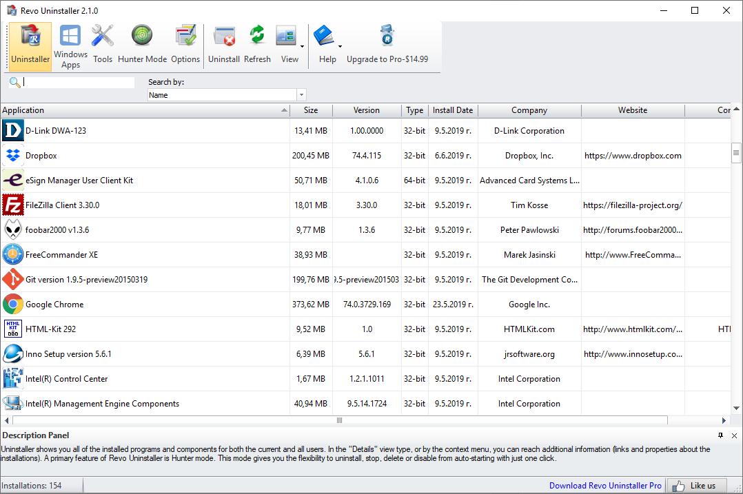

The main window of Revo Uninstaller is divided into few movable and flexible user interface components.

The Main toolbar contains some of the main features of Revo Uninstaller. By default it is located on the top of the main window. It contains some of the main features of Revo Uninstaller and the available commands for the currently active tool. Through the Tools button you can show the Tools toolbar with all existing additional tools. Both toolbars can be turned on and off from a context menu, and can be moved by dragging too (pressing the left mouse button over a part of the toolbar different than a button). You can show or hide the text of the icons from the options. The size of the icons can be changed from the options too.

At the bottom of the main window is the Status Bar. Depending on the active tool it can show some additional information.
The Description Panel is by default located above the status bar. It shows some common information about the active tool. It can be turned on and off from the context menu and it can be moved by dragging (pressing the mouse button anywhere in its window). The Description Panel supports also an “auto hide” feature that hides and shows the panel on mouse over. To activate/deactivate the “auto hide” option press the small button with the shape of a pin in the right upper part of the panel window.

Currently active tool is shown in the middle part of the main window. There could be only one active and visible tool at a given moment.

- Uninstaller

When Revo Uninstaller is started, its main window shows installed programs on your computer. Depending on the settings, other items, such as system updates or system components may be listed also. Depending on the view setting, programs are shown as Icons, List, and with Details such as Name, Size, Version, Type, Installation Date, Company, Comment, and Website.
From the uninstaller toolbar using the View drop-down button you can change the way that the list of applications may be viewed. Click on the little arrow on its right side. This will show you the menu with all view options - Icon, List and Details.
By default, installed programs are shown in Details view, where data is divided in columns. You can right-mouse click on the column header and show, hide and adjust some of the columns.
In Icons view and when you select a program, in the Description Panel, some of the properties of the program, like: Icon, Size, Version, Install Data, Company, Update Link and Web Site, are shown below. Similar data you may also see when you hover the mouse cursor over a program in the list. In that case the data is shown as Tooltip, next to the mouse cursor.

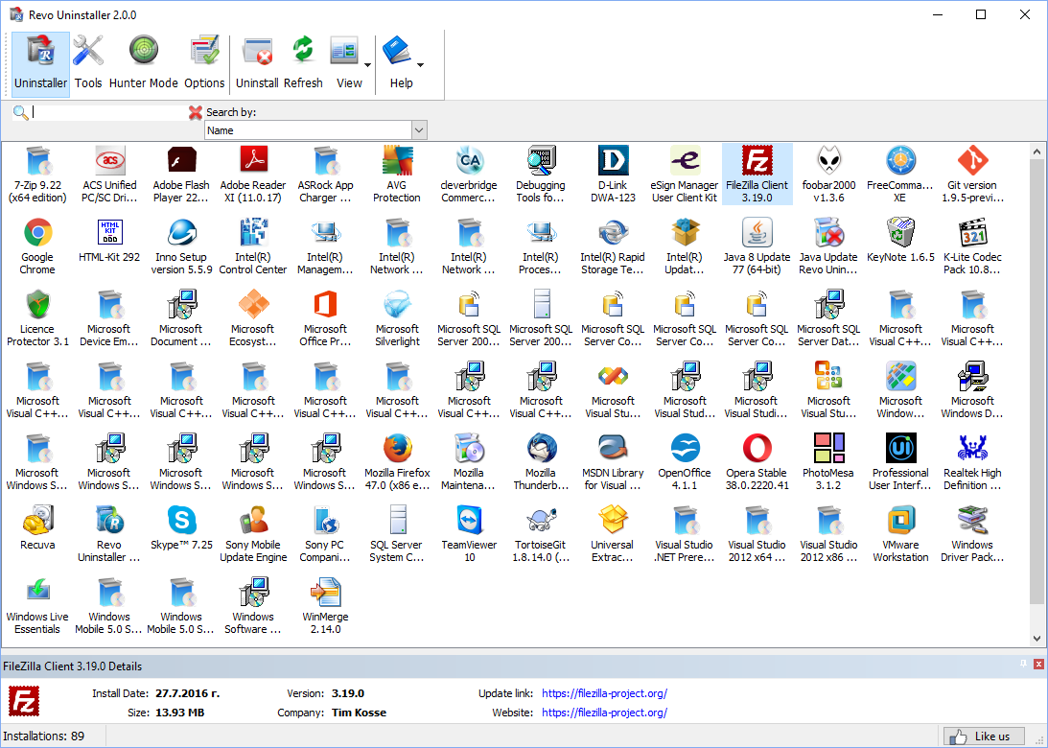

Using the Search field in the upper part of the main window, you can filter the list of the programs by name or company publisher. When you type some text in the Search field, right below you will see the number of found programs that match the search criteria.

Some commands available from the context menu are:
Uninstall – start the uninstall process of selected program
Search at Google for – Use it to search with Google for the application name, or the producer of the application. This command will open your default web browser and display the results of the search.
Open About Link – This command will open your default web browser and load the address containing information about the application.
Open Help Link – This command will open your default web browser and load the address containing help information.
Open Update Link – This command will open your default web browser and load the address providing update information.
Install Location – Opens Windows Explorer, so you can see where the selected application is installed.
Open Registry Key – Opens the registry editor (RegEdit.exe) and displays the registry key containing the uninstall information of the selected application.
Export list to – export installed programs to HTML, TXT. You can choose which details you can export.

The main command you can use on the list of installed programs is Uninstall.
If during the uninstall the build-in uninstaller of the programs runs "Change" or "Repair" command and tries to reinstall or repair the program instead of uninstalling it then you can use the command Forced MSI Uninstall. This command is visible in the context menu only for the MSI(Microsoft Installer) programs, which default uninstall command is not Uninstall. So if you experience such problem, just cancel the build-in uninstaller of the program and the uninstall wizard of Revo Uninstaller and start it again using this command from the context menu

In some cases, when a program from the list is selected, depending on the installer of that program, you may see on the Commands toolbar the command Change or Repair. That command is only shown when the installer of the program supports such functionality. Executing it will open a window, letting you change the modules of the installed program or repair its installation in case it does not work properly.
Refresh command refill the list of installed programs reading again the data from the Registry
Selecting a program and pressing Uninstall toolbar button will show up the Uninstall Wizard. Alternatively you can double left mouse click over the selected program or right-click on the selected item and then click the Uninstall command on the displayed menu.
After the Uninstall Wizard is shown Revo Uninstaller is going to create a system restore point (if it is not disabled in Options) and then it is going to run the built-in uninstaller of the uninstalled program. Revo Uninstaller is not directly involved in that part of the uninstall process. If errors occur during this initial uninstall process, contact the author or provider of the application! Or you can ignore the error message and continue the uninstall. After you have finished uninstallation with the built-in uninstaller, you have to press Scan button to continue the uninstall process with Revo Uninstaller.

NOTE: The built-in uninstaller may show up behind other open windows and you may need to switch between them by using the Alt+Tab key combination – hold Alt key and press Tab.

You can choose the scanning mode before the scan:
Safe - performs a scan in the Registry and the hard drive to find leftover items that are safe to delete. This is the fastest mode;
Moderate - includes the Safe mode and performs an extended scan to find all of the application's leftover information in the most common places of the Registry and the hard drive;
Advanced - includes the Moderate mode and performs a deep and thorough scan to find all of the application's leftover information in the Registry and on the hard drive. This is the slowest mode.

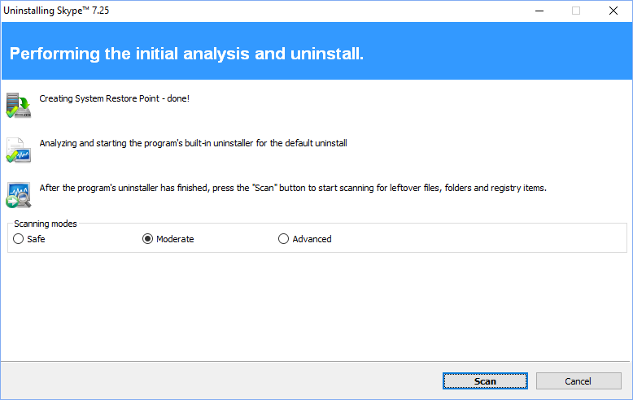

Pressing Scan button will trigger scanning for leftovers and the results (if any) will show up automatically. Revo Uninstaller shows found leftover Registry items first. Registry keys and values found as created by the uninstalled program are in bold. Not bold keys are considered as not created by the uninstalled program. You can also check mark them but they will not be deleted! They have check mark options just because it is easier to select the top parent and automatically check mark its sub items – no need to go through all of them and check mark them separately, so, whatever you check mark, when you press Delete button only check marked bold items are going to be deleted, even when Select All button is used.
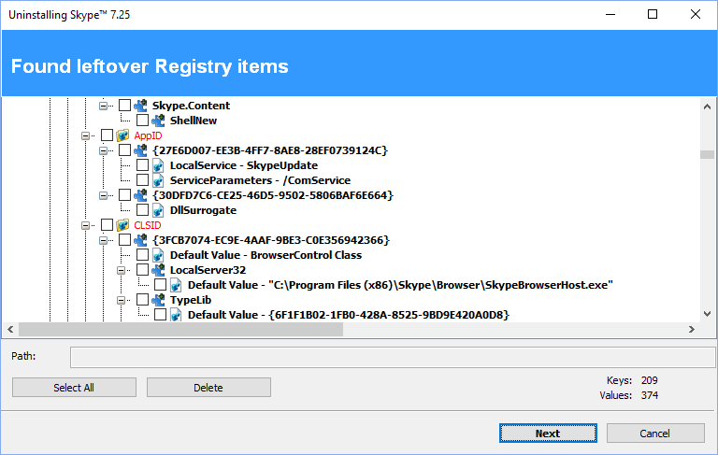
Revo Uninstaller contains advanced algorithms to find leftovers related only to the uninstalled program. In some cases these algorithms, especially in Advanced uninstall mode, could list some items related to another program. It could happen, but NOT necessarily (not always), when you have installed two or more versions of a program, for example "Adobe Photoshop CS" and "Adobe Photoshop CS5". In this case the user can distinguish the leftovers. It also could happen if you want to uninstall only a component of a big software package (i.e. a component of Microsoft Office). In that case Revo Uninstaller could list the rest of the components as leftovers, because they are installed in the same folder and Revo Uninstaller cannot distinguish them (Excel, PowerPoint, Word etc). It is better to use Revo Uninstaller to remove the whole software package instead of a component.
Revo Uninstaller also includes safety algorithms and will NOT list some leftovers if it decides that deleting them can harm your system. Therefore, although it does a better job than Windows Programs and Features application and the built-in uninstaller of the application you want to uninstall, it still may miss something due to safety and the uninstall mode you choose - Safe, Moderate and Advanced.
In Revo Uninstaller we have implemented a lot of protections to make it safer and secure, while trying to maximize its accuracy in searching for leftovers.
Basically you can easily distinguish the leftovers (by name, by install path) and in most of the cases Select All button could be safely used. There are GUIDs and CLSIDs (alphanumeric items) which are correct leftovers in 99% of the cases, so you can safely delete them.
Note that Revo Uninstaller creates a Windows System Restore Point and by default delete every deleted files or folder to the Recycle Bin.
There is also a context menu, which you can see by right-mouse clicking on the leftover items:
Expand All – expands all items of the shown Registry tree – by default it is expanded so you may not see any difference first time you use this command;
Collapse All – collapses all items of the shown Registry tree;
Export All – export shown leftover data to HTML file;
Expand selected key – expands only the selected key and its sub items;
Collapse selected key – collapses the selected key and its sub items;
Uninstall selected key – deletes the key from the system;
Mark selected key as Created – marks selected key as created by the program you are uninstalling. This feature is useful when you see a Registry key which you are sure is created by the program, but not marked as created because of the safety algorithms in Revo Uninstaller;

Warning: Be very careful using this command. Mark the key only if you are sure that it belongs to the uninstalled program!

Add to Exclude List – adds the selected key to the exclude list, which protects the key from deletion. Excluded keys have red color and you can edit the exclude list from options in Revo Uninstaller;
Open Registry Key… - open the selected Registry key in Windows Registry Editor (RegEdit.exe).

After finishing removal of the Registry leftovers you can press Next button and continue with the file and folder leftovers. Note that Next button may not be available if there are no other leftovers found.

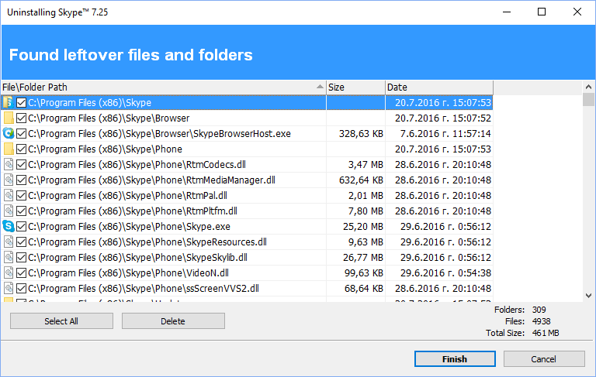

Revo Uninstaller shows you found leftover files and folders so you can check the results and delete them. You can see the number of leftover files and folders found.
Deleted files and folders are moved to the Recycle Bin by default, so you can recover them from there. You can change that option from Options -> Uninstaller.

There is a context menu, which you can use by right mouse-click on a file of folder:
Open – command on the context menu which acts the same way if you double click on a file or folder in Windows Explorer. Note that if there is no file association for the file you click on nothing will happen;
Properties – command on the context menu, which acts the same way if you right-mouse click on a file and choose Properties – shows properties like file size, attributes, date of creation, modification etc;
Open Containing Folder – opens the folder that contains selected item in Windows Explorer;
Export – exports the list of found leftover files and folders to a HTML file.

You can use Select All button to select all found leftover files and folders at once and then use Delete button to delete them.

- Windows Apps

The Windows Apps module lists all installed Windows apps, this includes built-in apps when you install Windows, and apps downloaded from Microsoft Store. The module helps you uninstall any app with a single click. To start the Windows Apps module press its button in the main toolbar

NOTE: Windows Apps module is available on Windows 8 and newer version of Windows.

The main window has a few columns with Name, Size, Install Date, Version, Publisher, and Description. Right clicking the header of a column allows you to change the alignment and choose which columns are shown. The entire list may be sorted by clicking a column header.

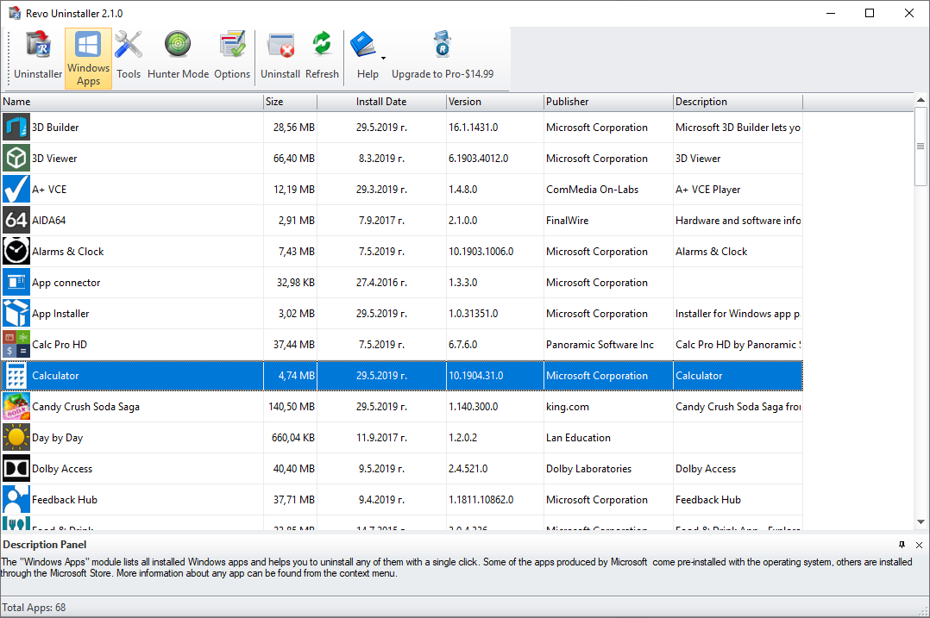

The main command is Uninstall - selecting an app and pressing the Uninstall button from the main toolbar will bring up the Uninstall Wizard. Revo Uninstaller tries to create a full Registry backup (if this is not disabled in the Options) and a System Restore Point, and then runs the default command to uninstall the app. After the app is uninstalled, you have to click the Scan button to continue the uninstallation process with Revo Uninstaller.

Revo Uninstaller shows found leftover Registry entries first. Registry keys and values found as created by the uninstalled program are in bold. Entries that are NOT in bold are considered as not created by the uninstalled program. You can safely check them (leave them checked), as they will not be deleted! Entries not in bold are displayed for two reasons: 1) for information: to give you a better idea of the tree structure, and 2) to make selecting leftovers for deletion easier and faster. You can simply check an entire parent branch, as that will automatically select all of its children. This eliminates the need to check each individual leftover item manually and separately. So, again, whatever items you check, when you press the Delete button, only entries that are checked and in bold will actually be deleted. This applies to when the Select All button is used as well.

You can bring up a context menu by right clicking. These are the available commands:
Expand All – expands all items in the Registry tree – by default it is expanded so you should not see any difference the first time you use this command.
Collapse All – collapses all items in the Registry tree.
Export All – export shown leftover data to an HTML file.
Expand selected key – expands the selected key and its sub items.
Collapse selected key – collapses the selected key and its sub items.
Uninstall selected key – deletes the selected key from the system.
Mark selected key as Created – marks the selected key as created by the program you are uninstalling. This feature is useful when you see a Registry key, which you are sure is created by the program but is not marked as created because of the safety algorithms in Revo Uninstaller.

Warning: Be very careful using this command. Mark the key only if you are absolutely certain that it belongs to the uninstalled program!

Add to Exclude List – adds the selected key to the exclude list, which protects the key from deletion, and marks it in red. You can edit the exclude list from the Options in Revo Uninstaller.
Open Registry Key… - opens the selected Registry key in the Windows Registry Editor (regedit.exe).

After removing the Registry leftovers, you can click the Next button, and continue to the file and folder leftovers. Note that the Next button may not be available if there are no other leftovers found.
Revo Uninstaller shows you found leftover files and folders so you can check the results, and delete the ones you want. Revo Uninstaller also displays the number of files and folders found, as well as their total size on the drive.
Deleted files and folders are moved to the Recycle Bin by default, so you can recover them from there. You can change that option in Options -> Uninstaller.
You can bring up a context menu by right clicking on a file or folder:
Open – acts the same way as if you double clicked on the file or folder in Windows Explorer. Note that if there is no program associated with the file, nothing will happen.
Properties – acts the same way as if you right clicked on a file, and chose Properties – shows various properties like file size, attributes, date of creation, modification, etc.
Open Containing Folder – opens the folder that contains the selected item in Windows Explorer.
Export – exports the list of found leftover files and folders to an HTML file.

You can use the Select All button to select all found leftover files and folders at once, and then use the Delete button to delete them.

To refresh the list of listed Apps you can use the command Refresh from the main toolbar.

Other commands available in the context menu for Windows Apps are:
Run – tries to start the app
Search at Google for – use it to search online using Google for the application’s name or publisher. This will open your default web browser and display the results of the search.
Install Location – opens the location where the app is currently installed in Windows Explorer.
Open in Microsoft Store – opens the app’s page in the Microsoft Store
Open Registry Key – opens the Registry editor (regedit.exe) and displays the Registry key containing the uninstallation information for the selected application.

- Hunter Mode


Hunter mode is an innovative and flexible feature of Revo Uninstaller, which gives you the ability to uninstall, stop or delete only by aiming applications icon on the desktop, quick launch toolbar, system tray or opened application with just one click. This can be very useful because a lot of applications are loading on start up and stay in the system tray without your agreement or you don’t even know which application is that.

When you press the Hunter mode button on the main toolbar of Revo Uninstaller, the current window will disappear and a small blue target window will appear at the right upper corner of your screen. Hunter mode is now activated.

There are some main options in Hunter mode, available on its context menu (right-mouse click):
Open main window – opens Revo Uninstaller’s main window and exits Hunter mode;
Auto Start with Windows – sets Hunter Mode to start automatically on Windows startup;
Always on top – if turned on, Hunter Mode’s window stays on the top of all other
opened windows. If turned off, the quickest way to view the Hunter Mode is to left click the
Revo Uninstaller Pro’s icon in the system tray.
Window's size – there are three available sizes of the current window – Small, Middle and Large;
Transparency - sets the Hunter Mode window’s transparency – 50% by default;
Help – opens help file;
EXIT – exits Revo Uninstaller.

To operate in Hunter mode you have to do the following steps:

1. Press the left mouse button over the blue target window and hold it pressed;
2. Move the mouse over an item supported by Hunter mode (desktop shortcut, open window, icon etc.). While doing so a tool tip is shown with information about the application you will select if you release the button;
3. Release the left mouse button and a menu will show up;
4. Select desired command from that menu:

Uninstall – start the Uninstall module of Revo Uninstaller;
Stop Auto Starting – disable the application from auto start when Windows starts;
Kill – Stop the application;
Kill and Delete – stop and delete the application;
Open Containing Folder - Open a new instance of windows explorer and explore the directory, where the application is located;
Search at Google for - Use it to search with Google for the application name, file name or the company name - producer of selected application. This command will open your default web browser and load the result of current search in the Google web site;
Properties - Show application's executable file's properties;
Cancel – Cancel the operation.

- Tools

Revo Uninstaller gives you 8 handy and powerful tools to clean up your system. To access the Tools you have to press the Tools button on the main toolbar. Then on the left side of the main window appears the Tools toolbar containing buttons of all the available tools: AutoRun Manager, Junk Files Cleaner, Windows Tools, Browsers Cleaner, MS Office Cleaner, Windows Cleaner, Evidence Remover, and Unrecoverable Delete

  - AutoRun Manager

Auto Run Manager allows you to manage auto running programs and services on Windows startup. With this tool you can not only enable or disable applications from auto starting on Windows startup but you can also get more information about a particular application set to run when Windows starts. You can get information about the publisher of the auto starting program or service, its description, its launch path - where it is saved on your computer or the status of the application - if it's running or not. If this information is not enough to decide whether to enable or disable the program from auto starting, you can get more information about the publisher and the executable file name directly from Google with just one right-mouse click.
When you buy a brand new computer it has no or few applications which are loaded at Windows startup. During the time you install new applications to your PC some of these applications are installed as auto starting on Windows startup. You can see some of them in the "system tray" (near the clock) as small icons. Often such applications are messengers, adware, advertisement programs and applications you do not need to start automatically.
When an application is started it takes resources such as RAM, CPU time. The amount of these resources depends on started applications but, no matter how much memory and resources it takes, when the number of started applications is bigger the slower is your computer.
If you want a program to start automatically when Windows starts, a common place to put the program is in the Startup folder of the Start Menu.
Some applications like anti-virus, firewalls and system programs must be started on Windows startup to keep your system running smoothly and without problems. Get as much information for an auto running program as possible and decide whether to enable or disable it.

The most common task you would like to do is to disable/enable an application from auto starting when the Windows operation system is started. This can be done with a single click; all you have to do is to uncheck/check the check box in front of the application name.

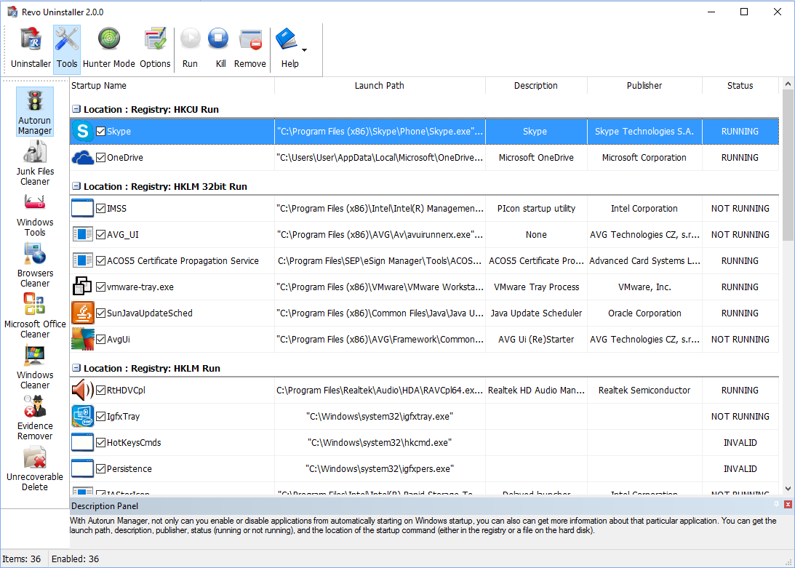

You can right-mouse click on the column header and show or hide some of the columns. This way you can also choose what to print.

There are several commands you can use in AutoRun Manager:
Run - You can run an application, which status is NOT RUNNING just by selecting the application in the list of applications and press Run button on the toolbar;

Kill - You can stop an application, which status is RUNNING just by selecting the application in the list of applications and pressing the Kill button on the toolbar;

Remove - If you want to remove an application from the list and prevent its auto loading when Windows is starting, you have to select the application and press Remove button from the toolbar. Note, that it is better to uncheck mark it only, because, in that way, it will be removed from startup but will remain in the list of AutoRun Manager, so you can check mark it again if you need it in future;

Set auto start for:
All users – if you want that program to start on every user login;
Current user – if you want that program to start when only current user is logged
Select to auto-start from:
Registry: Run – on every startup of Windows – this option will add startup setting to Windows Registry, which is common place for auto startups;
Registry: RunOnce – only once on the next startup of Windows – this option is similar to previous one but will start the program only once and then that Registry key will be deleted automatically by Windows;
Startup Folder – on every startup of Windows – this option will add a shortcut to the program in Startup folder, which is also a common place for startups and is accessible from Start menu -> All Programs.

There are more commands you can execute over a selected application:
Run Process - run selected application;
Kill Process - stop selected application;
Search at Google for - use it to search with Google for the selected start up name, file name, publisher name or description. This command will open your default web browser and load the result of current search in the Google web site;
Open containing folder - opens a new instance of windows explorer and explores the directory, where the selected application is located;
Go to Location - runs "Registry Editor" and opens the Registry key with auto starting information of the selected application;
Open Registry Key - opens "Registry Editor" and the Registry key with the uninstall information of the selected application;
Remove selected - remove selected application from the list;
Remove all not valid - remove all applications with status NOT VALID from the list;
Remove all not running - remove all applications with status NOT RUNNING from the list;
Remove all disabled - remove all disabled applications from the list;
Properties - show application's properties;
Open Windows Services - Opens the Windows Services management application and lets you get more properties and options to manage the services.

  - Junk Files Cleaner

Junk Files Cleaner allows you to find and remove various types of junk and unnecessary files from your computer. Many of the Windows applications create junk files. Normally, such files are deleted by the application that had created them as soon as it did not need them. However they may remain permanently on your hard drive if there is an unexpected termination of the parent application, a system crash, etc. If this happens, it will cause reduction of free disk space (even hundreds of megabytes), or may slow down system speed and performance.

With Junk Files Cleaner you can select which of your drives to scan and what extension of files to scan for. The most common temporary and junk files extensions are built-in, but you can also add whatever extension you want.

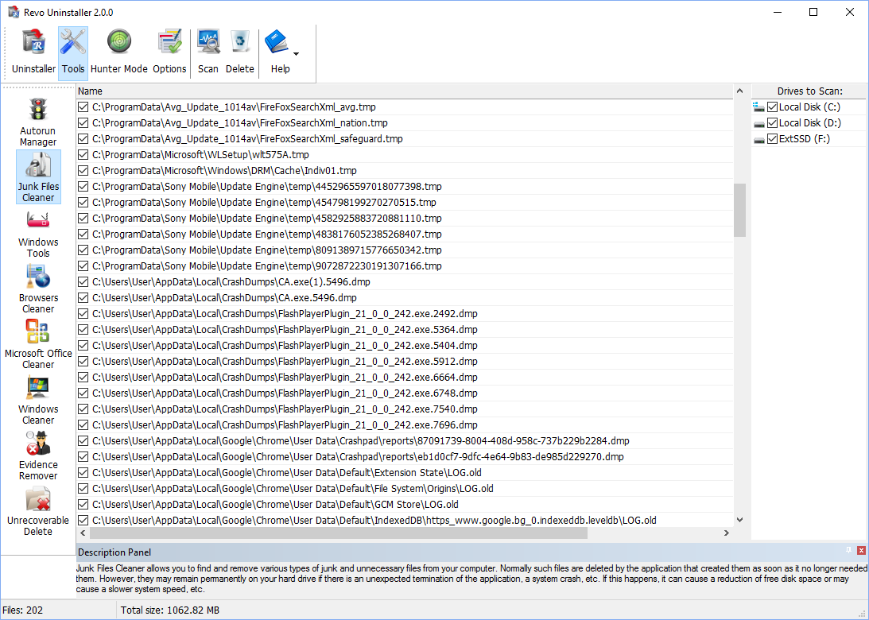

Commands of Junk Files Cleaner:
Scan - to start scanning for junk files, just press the Scan button from the current toolbar or from Command menu. This action will perform a scan operation with your current options. A small window appears to wait until the scan is complete. There is a "Cancel" button on that window, if you press it the scan process will be interrupted and you will only see the junk files found until that moment;
Delete - after the scan process is completed, all found files are loaded in the list with their full path, their name and their size. To delete any file of the shown press Delete button and all check files will be deleted;
There are more commands you can execute over selected file(s):
Open – open selected file;
Search at Google for – Use it to search with Google for the name of the selected file. This command will open your default web browser and load the result of the current search in the Google web site;
Open containing folder - Open a new instance of windows explorer and explore the directory, where the selected file is located;
Properties – Show file’s properties;
Check all items – Set a check in front of all items in the list;
Uncheck all items –Remove the check in front of all items in the list;
Check all selected items - Set a check in front of all selected items in the list;
Uncheck all selected items - Remove the check in front of all selected items in the list.
You can adjust settings on Junk Files Cleaner by pressing Options button in the toolbar or from the Tools menu.

  - Windows Tools

There are a lot of handy and useful tools and components bundled with every Windows operating system. Some of them have complex command line options, others are difficult to access. Windows tools give you a fast - one click - access to more than ten tools of Windows, which you use in your daily work. Almost all of them are included in Windows XP, Windows Vista and Windows 7.

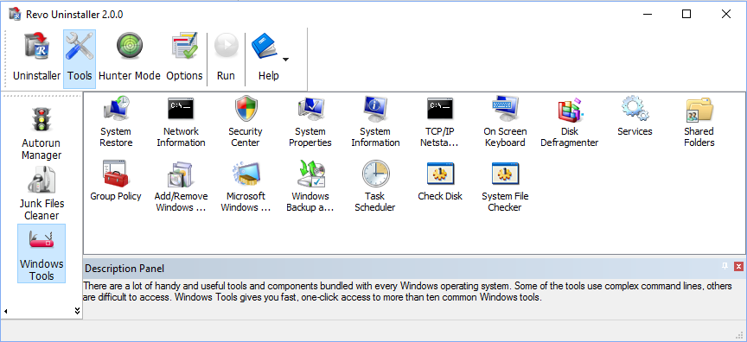
 | Windows  Windows Tools | XP |  | Vista |  | 7 |  | 8 (Pro) |  | 8.1 |  | 10 |  |  |  | Server 2012 R2
№ | Windows  Windows Tools | x86 | x64 | x86 | x64 | x86 | x64 | x86 | x64 | x86 | x64 | x86 | x64 |  | x64
1 | System Restore | √ | √ | √ | √ | √ | √ | √ | √ | √ | √ | √ | √
2 | Network Diagnostics | √
3 | Network Information | √ | √ | √ | √ | √ | √ | √ | √ | √ | √ | √ | √ |  | √
4 | Security Center | √ | √ | √ | √ | √ | √ | √ | √ | √ | √ | √ | √
5 | System Properties | √ | √ | √ | √ | √ | √ | √ | √ | √ | √ | √ | √ |  | √
6 | System Information | √ | √ | √ | √ | √ | √ | √ | √ | √ | √ | √ | √ |  | √
7 | TCP/IP Netstat Command | √ | √ | √ | √ | √ | √ | √ | √ | √ | √ | √ |  | √ |  | √
8 | On-Screen Keyboard | √ | √ | √ | √ | √ | √ | √ | √ | √ | √ | √ |  | √ |  | √
9 | Disk Defragmenter | √ | √ | √ | √ | √ | √ | √ | √ | √ | √ | √ |  | √ |  | √
10 | Services | √ | √ | √ | √ | √ | √ | √ | √ | √ | √ | √ |  | √ |  | √
11 | Shared Folders | √ | √ | √ | √ | √ | √ | √ | √ | √ | √ | √ |  | √ |  | √
12 | Group Policy | √ | √ | √ | √ | √ | √ | √ | √ | √ | √ (Pro) | √ |  | √ |  | √
13 | Add/Remove Windows Components | √ | √ | √ | √ | √ | √ | √ | √ | √ | √ | √ |  | √
14 | Microsoft Windows Malicious Software Removal Tool | √ |  | √ | √ | √ | √ |  | √ |  | √ | √ |  | √ |  | √
15 | Windows Backup and Restore | √ | √ | √ | √ | √ | √ | √ | √ | √ | √ | √ |  | √
16 | Task Scheduler | √ | √ | √ | √ | √ | √ | √ | √ | √ | √ | √ |  | √ |  | √
17 | Check Disk | √ | √ | √ | √ | √ | √ | √ | √ | √ | √ | √ |  | √ |  | √
18 | System File Checker | √ | √ | √ | √ | √ | √ | √ | √ | √ | √ | √ |  | √ |  | √

    - System Restore

System Restore is a component of the Windows operating system you can use to restore your computer to a previous state, if a problem occurs, without losing your personal data files (such as Microsoft Word documents, browsing history, drawings, favorites, or e-mail). System Restore monitors changes to the system and some application files, and it automatically creates easily identified restore points. These restore points allow you to revert the system back to a previous time. They are created daily and at the time of significant system events (such as when an application or driver is installed). You can also create and name your own restore points at any time.

    - Network Diagnostics

Network Diagnostics is a component of the Windows operating system you can use to gather and display information about your computer hardware and operating system, your internet configuration, and your modem and network adapter configuration. With the Network Diagnostics tool, you can perform a scan of your system and test network connectivity and whether or not your network-related programs and services are functional. It gathers a variety of basic information about the computer system, which can be helpful when given to a support person trying to help you troubleshoot your system. This tool is available only on Windows XP.

    - Network Information

Network Information uses a component of the Windows operating system you can use to display all current TCP/IP network configuration values and refresh Dynamic Host Configuration Protocol (DHCP) and Domain Name System (DNS) settings, Displays the full TCP/IP configuration for all adapters including IP address, MAC address, subnet mask, default gateway, Windows Internet Naming Service (WINS) and DNS configuration. Adapters can represent physical interfaces, such as installed network adapters, or logical interfaces, such as dial-up connections.

    - Security Center

Security Center is a component of the Windows operating system you can use to check the status of your computer for the three security essentials - Firewall, Virus protection software and Automatic Update. If a problem is detected with any of the three essentials (for example, if your antivirus program is out of date), the Security Center sends you an alert and provides recommendations on how to better protect your computer.

    - System Properties

System Properties is a component of the Windows operating system you can use to do the following:

* View basic information such as your CPU type and RAM memory.
* View and change settings that control how your computer uses memory and finds certain information.
* Find information about hardware and device properties, as well as configure hardware profiles.
* View information about your network connection and logon profile.
* Report system and program errors to Microsoft or your system administrator when they occur.

    - System Information

System Information is a component of Windows operating system that collects and displays system configuration information for local and remote computers. This includes information about hardware configurations, computer components, and software, including signed drivers and unsigned drivers. System Information is a support tool that you can use to quickly locate information about your computer and its operating system

    - TCP/IP Netstat Command

TCP/IP Netstat Command is a component of the Windows operating system that displays all active TCP connections and the TCP and UDP ports on which the computer is listening and displays the executable involved in creating each connection or listening port. In this case the executable name is in [ ] at the bottom, on top is the component it called, and so forth until TCP/IP was reached. With simple words this command shows which applications are connected and on which port to the Internet and which are listening for incoming connections.

    - On-Screen Keyboard

On-Screen Keyboard is a component of the Windows operating system that displays a virtual keyboard on the screen, allowing users with mobility impairments to type data using a pointing device or joystick. On-Screen Keyboard is intended to provide a minimum level of functionality for users with mobility impairments. You can also use On-Screen Keyboard if you think that there is a Key-Logger installed on your PC and all the keys you type are being recorded. On-Screen Keyboard eliminates the possibility of recording typed keys.

    - Disk Defragmenter

Disk Defragmenter is a component of the Windows operating system that analyzes local volumes and consolidates fragmented files and folders so that each occupies a single, contiguous space on the volume. As a result, your system can access files and folders and save new ones more efficiently. By consolidating your files and folders, Disk Defragmenter also consolidates a volume's free space, making it less likely that new files will be fragmented. The process of consolidating fragmented files and folders is called defragmentation. After defragmentation your hard disk drive will be well-arranged and your system will work faster and with ease.

    - Services

A service is a type of applications that run in the background. Service applications typically provide features such as client/server applications, Web servers, database servers, and other server-based applications to users, both locally and across the network. Services is a component of Windows operating system you can use to:

* Start, stop, pause, resume, or disable a service on remote and local computers. You must have the appropriate permission to start, stop, pause, restart, and disable services.
* Manage services on local and remote computers.
* Set up recovery actions to take place if a service fails, for example, restarting the service automatically or restarting the computer.
* Enable or disable services for a particular hardware profile.
* View the status and description of each service.

    - Shared Folders

Shared Folders is a component of the Windows operating system you can use to manage shared resources over a network, control user access permissions, session activity, shared resource properties and to view a summary of connections and resources, uses for local and remote computers. With Shared Folders, you can:

* Create, view, and set permissions for shared resources.
* View a list of all users connected over a network to the computer, and disconnect one or all of them.
* View a list of files that have been opened by remote users, and close one or all of the open files.

    - Group Policy

Group Policy is a component of the Windows operating system that includes policy settings for User Configuration, which affect users, and for Computer Configuration, which affect computers. Group Policy settings define the various components of the user's desktop environment that a system administrator needs to manage, for example, the programs that are available to users, the programs that appear on the user's desktop, and options for the Start menu. To create a specific desktop configuration for a particular group of users, use the Group Policy snap-in.

    - Add/Remove Windows Components

Add/Remove Windows Components helps you manage installed Windows components on your computer. After Windows OS is installed on your computer, you can use the Add/Remove Windows Components to add a Windows component that was not included in the original installation, or to remove an existing Windows component that you no longer require.

    - Microsoft Windows Malicious Software Removal Tool

The Microsoft Windows Malicious Software Removal Tool checks computers running a Windows operating system for infections by specific, prevalent malicious software, and helps remove any infections found. This malicious software includes viruses, worms and Trojan horses. When the detection and removal process is complete, the tool displays a report describing the outcome, including, if any malicious software was detected and removed.

    - Windows Backup and Restore

Windows Backup and Restore allows you to make copies of data files for all people who use the computer and provides you with the ability to create a system image. You can let Windows choose what to back up or you can select the individual folders, libraries, and drives you want to back up. A system image includes Windows and your system settings, programs, and files. You can use a system image to restore the contents of your computer if your hard drive or computer ever stops working.

    - Task Scheduler

Task Scheduler helps you schedule automated tasks that perform actions at a specific time, or when a certain event occurs. It provides the ability to schedule the launch of programs or scripts at pre-defined times, or after specified time intervals. Task Scheduler maintains a library of all scheduled tasks, providing an organized view of the tasks and a convenient way to manage them.

    - Check Disk

Check Disk opens a command prompt window to execute the chkdsk.exe Windows command. Check Disk verifies the logical integrity of the file system on the Windows volume. Check Disk checks for problems related to bad sectors, lost clusters, cross-linked files, and directory errors. These types of problems can be caused by system crashes or freezes, power glitches, incorrectly turning off a computer, etc.

    - System File Checker

System File Checker allows you to scan for and restore corruptions in Windows system files, verifying their versions. If it finds a problem, it will attempt to replace the problematic files from the Windows DLL Cache. If the file is not in the Windows DLL Cache or the DLL Cache is corrupted, you will be prompted to insert the Windows installation disk.

  - Browsers Cleaner

Your browser makes a detailed record of every web site you've ever visited. It's easily accessible from your browser window and simply by pressing a button anyone can see where you've been browsing on the web. Revo Uninstaller erases web site history of web browsers including Internet Explorer, Firefox, Google Chrome and Opera. With Browsers Cleaner you can also delete temporary internet files, which are all the pictures you've seen, all the online videos you've watched and all the web pages you've visited. Deleting Temporary Internet Files will free a lot of space on your hard disk.

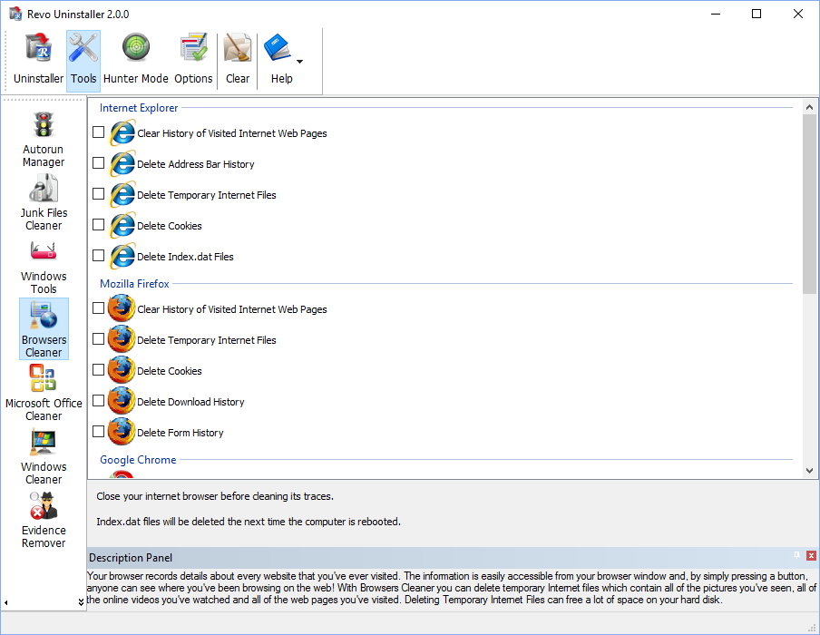

Depending on the history setting you want to cleanup and the browser you have, you have to check mark these options and press the Clear toolbar button or the Clear command on the Commands menu. For faster check\uncheck of items you can use the right-click menu command and check\uncheck all items of specific browser or all items in the list.

  - Microsoft Office Cleaner

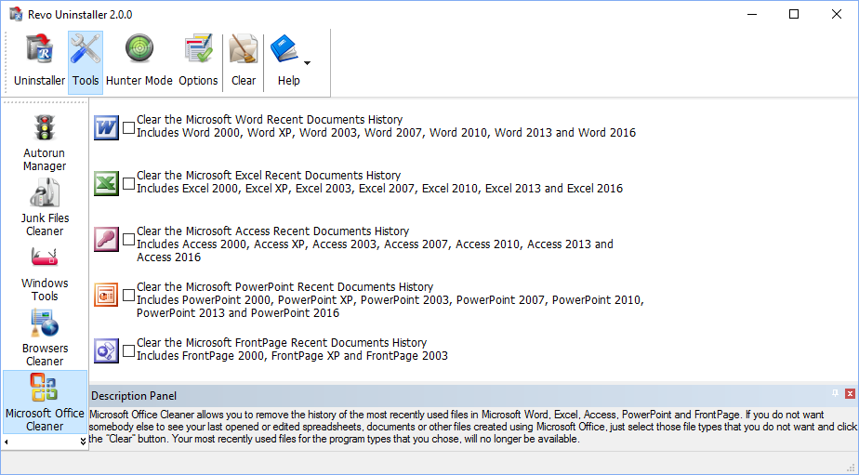

MS Office Cleaner allows you to remove history of most recently used files in MS Word, Excel, Access, PowerPoint and Front Page. If you do not want somebody else to see your last opened or edited spreadsheets, documents or other files created using MS Office, just select those you do not want others to see and click the Clear button. Your most recently used files will no longer be listed. Windows also keeps a record of your recent files. Use MS Windows Cleaner included in Revo Uninstaller to clear them too.

MS Office Cleaner includes the following options to clarify most recently used files of:

Microsoft Excel 2000, XP, 2003, 2007, 2010, 2013 and 2016
Microsoft Word 2000, XP, 2003, 2007, 2010, 2013 and 2016
Microsoft PowerPoint 2000, XP, 2003, 2007, 2010, 2013 and 2016
Microsoft FrontPage 2000, XP, 2003
Microsoft Access 2000, XP, 2003, 2007, 2010, 2013 and 2016

Depending on the program, which history settings you want to cleanup, you have to check mark it and press the Clear toolbar button or the Clear command on the Commands menu. For faster check\uncheck of items you can use the right-click menu command and check\uncheck all items of in the list.

  - Windows Cleaner

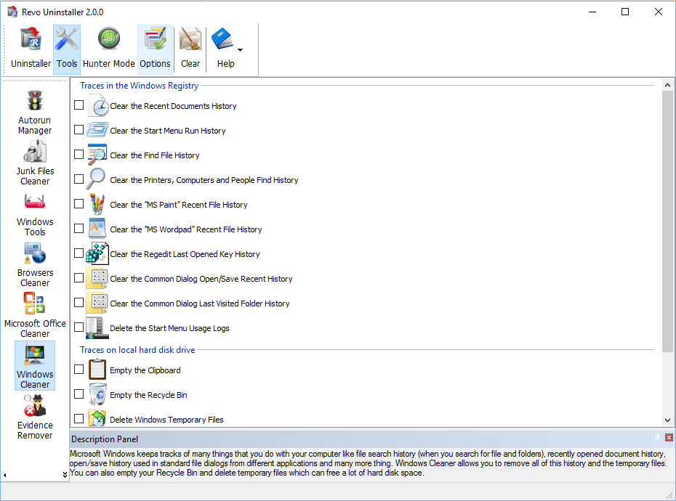

Microsoft Windows keeps tracks of many things you do with your computer, like file search history when you search for file and folders; recently opened document history; open/save history used in standard open/save dialogs from different applications installed on your computer; start menu clicks history; last opened Registry key history and more. Windows Cleaner allows you to remove all this history and temporary files. It's a useful tool, because you can remove all this history from one place quickly and easily. You can also empty your Recycle Bin and delete temporary files, freeing more disk space.

Available options of Windows Cleaner are:

Clear Recent Documents History;
Clear Start Menu Run History;
Clear Find File History;
Clear Printers, Computers and People Find History;
Empty Clipboard;
Clear “MS Paint” Recent Files History;
Clear “MS WordPad” Recent Files History;
Clear “Regedit” Last Opened Key History;
Clear Common Dialog Open Save Recent History;
Clear Common Dialog Last Visited Folder History;
Empty Recycle Bin;
Delete Windows Temporary Files;
Delete Start Menu Click Logs;
Delete crash memory dump files;
Delete Chkdsk (Check Disk) recovered file fragments;
Delete Thumbnail Cache.

Depending on the history item you want to clean up, you have to check mark that option and press the Clear button on the toolbar or the Clear command on the Commands menu.
For faster check\uncheck of items you can use the right-click menu command and check\uncheck all items of in the list.

  - Evidence Remover

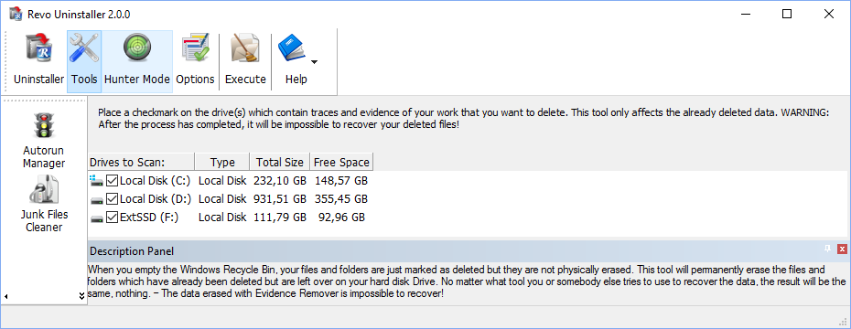

Deleting your files and folders does not mean that they are gone forever. When you empty Windows Recycle Bin your files and folders are just marked as deleted but they are not physically erased. There is a chance to recover deleted data from 10 years or older PC and this data may be very important and confidential. You can easily get back your important documents and other files that you have deleted using any recovery tool or un-delete program. This is where the Evidence Remover tool of Revo Uninstaller comes. Evidence Remover will eliminate all chances to get data back from your hard drive. It will forever erase files and folders already deleted, but left physically on your hard disk. No matter what tool you or somebody else will use to recover the data, including professional and expensive recovery and un-delete tools, the result will always be the same - the data erased with Evidence Remover is impossible to recover.
To erase already deleted files and folders you have to check mark the drive where these files are deleted from. Then you have to press the Execute toolbar button or the Execute command from the Commands menu.

The process is slow, because the data is overwritten 3 times randomly. The speed depends on:
- Computer Processor (CPU);
- The size of the selected drive;
- Running programs;
- Running security software – anti-virus, Internet Security, etc.

During the process, the free disk space decreases, because Evidence Remover creates a very huge file and writes random data in it. That huge file is deleted at the end of the process – the free disk space is restored.

  - Unrecoverable Delete

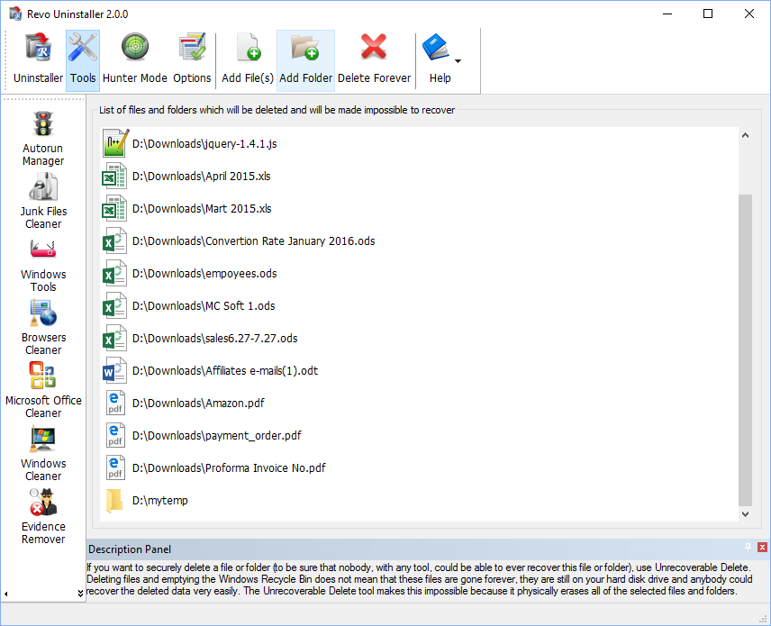

If you want to securely delete a file or folder and to be sure that no one, with any tool, could be able to recover this file or folder, then use Unrecoverable Delete. Deleting files and emptying Windows Recycle Bin does not mean these files are gone forever. They are still on your Hard Disk Drive or other storage, but marked as deleted. Anyone, with a tool available free or commercial, could recover deleted data very easily. Revo Uninstaller’s Unrecoverable Delete tool makes this impossible, even if you try to do that with the most advanced and expensive tool on the market. Deleting files in Windows means that they are marked as deleted and the space they allocated is free to use. This is because, if Windows has to physically erase all deleted files, it will take time and will slow down your computer. Beside this, there is a lot of system, temporary and other files not so important to be unrecoverable. Unrecoverable Delete physically erases all the files and folders and that's why it takes more time than simple deleting.

Unrecoverable Delete has the following commands:
- Add File(s) – using this command you can add files for unrecoverable delete from different folders and disk drives;
- Add Folder – using this command you can add a folder for unrecoverable delete. All sub folders and files will be deleted permanently;
- Delete Forever – executes permanent erasing of the added files and folders. You can cancel the process, but files, erased before the cancel will be unrecoverable, so please carefully select the files and folder you want to delete.

The window of the Unrecoverable delete tool supports drag and drop of files and folders. Because Revo Uninstaller has administrative rights, programs with lower rights cannot drop files and folders in it. For example, if you run Windows explorer or any other file manager with standard user account (not as administrator), you will not be able to drag and drop files in Unrecoverable delete tool.

- Options
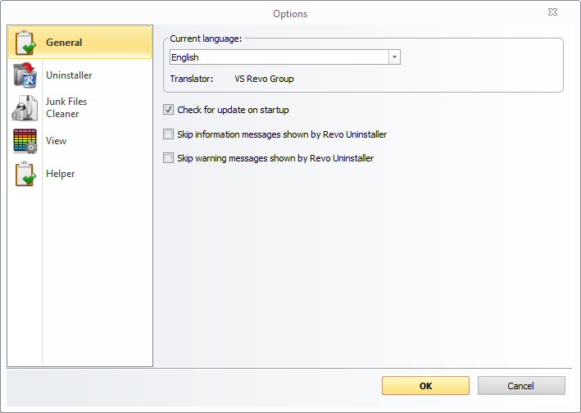

  - General

Here you can find some general options of Revo Uninstaller like:
Current Language: - drop down box, which you can use to change the localization of Revo Uninstaller. Note, that it is set when you install Revo Uninstaller to the language you choose on install;
Check for update on startup – Revo Uninstaller will check if there is a new version available by connecting to www.revouninstaller.com on startup, but only once a day. No personal information is sent or received. Note, that you have to allow Revo Uninstaller to connect to the Internet in your firewall settings;
Skip information messages shown by Revo Uninstaller – if you do not want to see information messages from Revo Uninstaller enable this option. Information messages are messages like “Revo Uninstaller finished scanning for leftovers”;
Skip warning messages shown by Revo Uninstaller – if you do not want to see warning messages from Revo Uninstaller, enable this option. Warning messages are messages like “Are you sure you want to remove selected item?”;

  - Uninstaller
    - General

Here are the main options affecting the whole uninstaller:
Show system updates (not supported in Windows Vista and Windows 7,8,10) – the option shows Windows updates on Windows XP;
Show system components – some programs have additional components which are removable but marked as a component of another program and by default Revo Uninstaller does not list this kind of programs;
Use program's uninstall data to get the Install Date property - if this option is turned on Revo Uninstaller gets the installation dates of the installed programs from their own Uninstall data written by their built-in uninstalled in the Registry. Otherwise it uses other Registry data to get the installation dates
Enable fast loading mode - if the mode is enabled Revo Uninstaller starts much faster skipping the loading of the icons and calculation of the size for the programs that haven't provided such one.
Only run the built-in uninstaller - when you select the Uninstall command Revo Uninstaller will start only the built-in uninstaller of the selected program;
Make a System Restore Point before uninstall – If Windows System Restore is enabled Revo Uninstaller requests from it creation of a system restore point;
Open the Uninstall wizard maximized - this option causes the window of the Uninstall Wizard to be shown always maximized for better review of the leftovers;
Check mark all leftovers by default - leftovers as Registry items, files and folders, found by Revo Uninstaller, will be check marked automatically.
NOTE: When Delete button is clicked ONLY check marked bold items will be deleted, even if all items are check marked!
Forcibly stop running executable files during their uninstall – if this is turned on, and Revo Uninstaller is trying to uninstall an executable file(s), then Revo Uninstaller will try to stop that file(s) forcibly. This will prevent some running files from remaining on the system until the next restart or even after that;
Delete leftover files and folders to the Recycle Bin - if the option is check marked Revo Uninstaller deletes found as leftover files and folders to the Recycle Bin.

    - Exclude

There are two types of items you can exclude during uninstall – Registry items and folders.
When a program is uninstalled, Revo Uninstaller shows the leftover Registry items and some of the items we know for sure that are not created by the uninstalled program, so, we have an exclude list for these items. You are also able to add or remove such items (using Add and Remove buttons) or Reset Defaults – remove all added and restore all removed items.

A Registry key could be excluded only by adding the full path to the key for example:
HKEY_LOCAL_MACHINE\SOFTWARE\Classes

There is an option for each Registry key called Include Sub keys, which can be check marked. That option will exclude all sub keys of that Registry key – not only the key itself.

In front of each Registry key there is a check box, which is used to enable or disable (depending on whether it is check marked or not) the exclusion of a Registry key. If there is a check mark the key is considered as excluded.

Exclude list supports wild cards as (?) and (*), which means you can exclude several keys at once or without knowing the exact name of that particular Registry key. For example:
HKEY_LOCAL_MACHINE\SOFT????\Classes
This will exclude all Registry keys in HKEY_LOCAL_MACHINE beginning with SOFT and having 4 characters following SOFT word, because the (?) sign means any character.

HKEY_LOCAL_MACHINE\SOFT*\Classes
This will exclude all Registry keys in HKEY_LOCAL_MACHINE beginning with SOFT word and no matter how they end – any length, any characters after the SOFT word. You can use (*) char to replace the whole key name as:
HKEY_LOCAL_MACHINE\*\Classes
But this also will exclude the whole branch like:
HKEY_LOCAL_MACHINE\SOFTWARE\Classes
HKEY_LOCAL_MACHINE\HARDWARE\Classes
HKEY_LOCAL_MACHINE\Microsoft\Classes
HKEY_LOCAL_MACHINE\Your Company\Classes
HKEY_LOCAL_MACHINE\Anything goes here\Classes

You can also use a combination of (?) and (*).

If it is necessary by some reason when a program is uninstalled you can exclude certain folders from the list of found leftovers. You can add folders to the list using Add button and browse to the folders you want to exclude. You can also Remove added folder or just uncheck mark it, which will remove it from consideration as excluded.

  - Junk Files Cleaner

You can add processes to be included in the monitoring using Add button and specify full path to the process. You can also Remove added processes or just uncheck mark them, which will remove them from consideration as included. Reset Defaults button will remove all added processes and add default ones.

    - General

Delete files to the Recycle Bin - if this option is check marked all junk files are moved to the Recycle Bin. This can be considered as additional safety but will not increase the free disk space until you empty your Recycle Bin.

Ignore files accessed last 24 hours - this option is enabled by default, because some junk and temporary files are in use during the scan for junk files and it is better to leave them.

There is a list of patterns (mostly file types), and their description, where you can select which pattern to scan for when scan operation is performing. Files matching with a given pattern will be shown in the result list only if there is a check mark before the pattern. If you remove a check mark, the pattern after it will not be taking into consideration while scanning is being done.
You can also add or remove patterns from the list by using the buttons underneath. To add new pattern press button Add and a small window will appear, where you can type the desired pattern using wild cards (?,*) and press OK to add it to the list or Cancel to ignore operation.
To remove a pattern, select it in the list and press the Remove button. If you want to restore the default built-in patterns, just press Set Default button and all of your patterns will be deleted and returned to the default.

    - Exclude

If you wish to exclude any files contained within any directory from a scan, there is a list with patterns of paths on the local drives, where you can select which pattern to be scanned while the scan operation is performing. Directories matching with a given pattern will be skipped in the scan process only if there is a check mark before the pattern. If you remove a check mark, the pattern after it will be scanned for unnecessary files.
You can also add or remove patterns from the list by using the buttons underneath. To add a new pattern press the Add button and a small window will appear, where you can type desired pattern using wild cards (?,*) and press OK to add it to the list or Cancel to ignore operation.
To remove a pattern, select it in the list and press the Remove button. If you want to restore the default built-in patterns, just press the Set Default button and all your patterns will be deleted and returned to the default

  - View

Some visual aspects of Revo Uninstaller can be changed and adjusted here.
You can adjust whether the toolbars should have text labels and if the icons of the toolbars should be small or large. Turn on the Show small icons in Details view option if you want to view small icons in Details view of the Uninstaller and AutoRun Manager.
Reset main window panels settings command resets position and size of the panels of main window of Revo Uninstaller - toolbars, status bar, description panel
Reset Details view control settings command resets the customization (all column changes) of the details view control on the tools that have such view type like the Uninstaller and AutoRun Manager.

  - Revo Uninstaller Helper

It is a tool designed to assist with thorough removal of leftovers after incomplete uninstallations, even if Revo Uninstaller was not used during the uninstall process

Offers several options for the Helper module, including deactivating.
- Enable Revo Uninstaller Helper – activates or deactivates the Helper.
- Show found leftover notifications – allows the Helper to display notifications for any leftovers that were found during a background scan after an uninstall of a program without Revo Uninstaller

